 |  | 
MUITINĖS DEPARTAMENTAS PRIE LIETUVOS RESPUBLIKOS FINANSŲ MINISTERIJOS |  | NETCOMPANY INTRASOFT

Service Contract No. 11BE-24 14.02.2023
DEVELOPMENT (PHASE II), AND MAINTENANCE AND SUPPORT SERVICES OF THE NATIONAL TRANSIT CONTROL SYSTEM
NTKS (NCTS-P6)
Trader Interface Specifications

(Excerpt from DDNTA 6.4.0-v2.00 for NCTS P6
with national LT requirements)

Document ID: | LT-NTKS-TIS-EN
Document version: | V4.00

Document History
Version | Release Date | Author | Description
0.10 | 22/12/2023 | NCIS | First draft
0.20 | 05/01/2024 | LC | Comments
0.30 | 31/01/2024 | NCIS | Submitted for Review (SfR)
0.40 | 06/02/2024 | LC | Comments
0.50 | 12/02/2024 | NCIS | Submitted for Review (SfR)
1.00 | 14/02/2024 | NCIS | Submitted for Acceptance (SfA)
1.10 | 31/05/2024 | NCIS | Adding Appendix SOAP
1.20 | 04/06/2024 | NCIS | Section “Supplementary Data for Linking and Balancing” and Appendix L&B have been removed. Message IELB20LT is no longer required from the economic operator, information relevant to linking and balancing shall be provided as part of the IE015 message in new NTKS application (compliant to NCTS Phase 5). Consequently, IELB21LT will not be used as well.
2.00 | 20/08/2024 | NCIS | Aligned with DDNTA 5.15.2
2.10 | 20/11/2024 | NCIS | Applied changes in IE007, added data elements relevant to IRU TIR movements
3.00 | 30/06/2025 | NCIS | Aligned with DDNTA 6.4.0-v2.00 for NCTS P5
4.00 | 17/02/2026 | NCIS | Section for Electronic Transport Document (ETD) added.

Table of Contents
Table of Contents 3
List of Tables 4
List of Figures 4
I General Introduction 6
I.I Document Overview 6
I.I.1 Purpose and scope of TIS document 6
I.I.2 Intended audience 6
I.I.3 Structure of TIS document 7
I.II Acronyms and Abbreviations 8
I.III Applicable documents 9
II NCTS-P6 including National LT Requirements 10
II.I Introduction 10
II.I.1 NCTS Actors relevant for External Domain 10
II.I.2 Physical movements 11
II.I.3 Reference Data 11
II.I.4 Summary of the national LT requirements in NTKS Phase 6 11
II.I.5 Time Sequence Diagrams versus State Transition Diagrams 12
II.II Time Sequence Diagrams and Other Requirements 12
II.II.1 Specific Scenarios at Office of Departure (DEP) 12
II.II.2 Specific Scenarios at Office of Transit (TRT) 38
II.II.3 Specific Scenarios at Office of Destination (DES) 40
II.II.4 Specific Scenarios for Incidents “En Route” (INC) 52
II.II.5 Enquiry & Recovery 54
II.III Introduction to ETD (Electronic Transport Document) 56
II.III.1 Relationship between ETD and NCTS at Departure 57
II.III.2 Arrival at Destination – Air Transport (ETD) 57
II.III.3 Message Exchange Principles 58
III APPENDICES 60

List of Tables
Table 1: Acronyms and Abbreviations 8
Table 2: Applicable Documents 9
Table 3: Roles and organisations in NCTS relevant for External Domain 11
Table 4: Mapping of standard NCTS messages and NCTS-ETD equivalent messages 59

List of Figures
Figure 1: T-TRA-DEP-A-003-Transit presentation notification valid 15
Figure 2: T-TRA-DEP-A-002-Correction of the pre-lodged declaration prior to presentation of goods 17
Figure 3: T-TRA-DEP-E-004-Transit presentation notification not valid 18
Figure 4: T-TRA-DEP-E-005-Cancellation of the pre-lodged declaration prior to presentation of goods 19
Figure 5: T-TRA-DEP-M-001-Normal procedure at departure 20
Figure 6: T-TRA-DEP-A-001-Simplified procedure at departure 22
Figure 7: T-TRA-DEP-E-012-Rejection of transit declaration 23
Figure 8: T-TRA-DEP-A-014-Declaration amendment accepted 25
Figure 9: T-TRA-DEP-E-015-Declaration amendment rejected 26
Figure 10: T-TRA-DEP-M-006-Control by Office of Departure with release for transit 28
Figure 11: T-TRA-DEP-A-010-Control by Office of Departure with release for transit refused 30
Figure 12: T-TRA-DEP-A-046-Request for additional documents during control 32
Figure 13: T-TRA-DEP-A-013-Release for transit refused due to guarantee registration failure 34
Figure 14: T-TRA-DEP-A-016-Invalidation request by the Holder of the Transit Procedure before release for transit – Accepted 36
Figure 15: T-TRA-DEP-A-016-Invalidation request by the Holder of the Transit Procedure before release for transit – Rejected 37
Figure 16: T-TRA-DEP-A-017-Invalidation request by the Holder of the Transit Procedure after release for transit 38
Figure 17: Arrival Notification by the Holder of the Transit Procedure at the Customs Office of Transit 39
Figure 18: Arrival Notification by the Holder of the Transit Procedure at the Customs Office of Transit - Invalidated 40
Figure 19: T-TRA-DES-M-001-Arrival notification valid under normal procedure with no control or control with satisfactory control results 42
Figure 20: T-TRA-DES-A-004-Simplified procedure at destination 44
Figure 21: T-TRA-DES-A-006-Unloading permission received–unloading remarks 47
Figure 22: T-TRA-DES-E-007-Unloading remarks rejected 48
Figure 23: T-TRA-DES-E-003-Rejection of arrival notification 49
Figure 24: T-TRA-DES-A-008-Major Discrepancies found during control at the Office of Destination – Resolved before the expiration of resolution timer 52

General Introduction

Document Overview

Purpose and scope of TIS document
The Trader Interface Specifications (TIS) document is an excerpt from the DDNTA document relevant to economic operators who interact with NCTS Phase 6 (NCTS-P6) application of Customs Department of Republic of Lithuania – NTKS. The TIS specifies the design requirements to which any economic operator needs to conform to be able to submit declarations, including the Electronic Transport Document (ETD), and process transit movements with Lithuanian Customs as per NCTS Phase 6 requirements.
The TIS is applicable to every NCTS-P6 application of the economic operators and must be considered as a mandatory document for all implementation and verification activities.
This document is an excerpt from the DDNTA 6.4.0-v2.00 for NCTS P6 that includes LT national requirements.
Information Exchanges covered in this document are in the External Domain (between National Administration and Economic Operators).
In order to construct their NCTS-P6 applications, the economic operators interacting with Lithuanian Customs should therefore use this document.
The purpose of the TIS document is to state unambiguously what needs to be developed. This is achieved by specifying the sequences of Information Exchanges to be supported, in the form of message exchanges. The detailed structure and building rules of these Information Exchanges are described several appendices to this document, namely appendices MSG, XSD, and R.
How the Information Exchanges, have to be performed and transported (technical exchange protocol) between the economic operator’s application and NTKS is also described in the dedicated Appendix to TIS, namely appendix SOAP.
And last but not least, TAD printing guidelines are also provided in the dedicated appendix TAD to this document.

Intended audience
The intended audience for this document is the economic operators who develop applications that interact with NTKS.
The readers are assumed to have a good understanding of the IT concepts and terminology used in this document. Also, it is assumed that the readers are familiar with NCTS.

Structure of TIS document
The TIS document specifies the NTKS specifications covering NCTS-P6 message exchanges relevant to economic operators who interact with NTKS. It is structured in sections (further subdivided in sub-sections) and appendices.
This document comprises the sections and lists of appendices summarised below.
I GENERAL INTRODUCTION includes the following:
I.I describes the purpose and the scope of the TIS document, the intended audience, and the internal structure of the document;
I.II contains acronyms and abbreviations used in this document;
I.III provides list of applicable documents;
II NCTS-P6 describes the Core Business relevant to external domain of the NCTS-P6 including the Electronic Transport Document (ETD).
This section contains a detailed definition of the message exchanges to be supported for the different Business Processes. These message exchanges are described by a collection of Time Sequence Diagrams.
III APPENDICES
- Appendix MSG contains the definition of external domain messages for ETD and NCTS-P6;
- Appendix XSD contains the XML Schemas of the external domain NCTS-P6 messages;
- Appendix XSD-ETD contains the XML Schemas of the external domain ETD messages;
- Appendix R of the DDNTA contains mapping of names of message data groups and data elements to names of XML elements of NCTS-P6 messages;
- Appendix SOAP contains the technical message exchange protocol for the external domain ETD and NCTS-P6 messages;
- Appendix TAD contains Guidelines for the Printout of the Transit Accompanying Document (TAD) and the Transit List of Items (TLoI) issued by DG TAXUD.

Acronyms and Abbreviations
The following acronyms and abbreviations are used in this document:
Acronym | Description
APP | Appendix
DDNTA | Design Document for National Transit Applications
DEP | Departure
DES | Destination
EN | English
ENQ | Enquiry
ETD | Electronic Transport Document
IE | Information Exchange
INC | Incident
IT | Information Technology
L&B | Linking & Balancing
LRN | Local Reference Number
LT | Lithuanian
MRN | Master Reference Number
MSG | Message
NCTS | New Computerised Transit System
NTKS | National Transit Control System
P5 | Phase 5
P6 | Phase 6
R/C | Rules and Conditions
REC | Recovery
SOAP | Simple Object Access Protocol
TAXUD | Taxation and Customs Union DG
TIS | Trader Interface Specifications
TRA | Transit
UCC | Union Customs Code
XML | eXtensible Mark-up Language
XSD | XML Schema Definition
Table 1: Acronyms and Abbreviations

Applicable documents
The following documents are applicable to this document:
Ref. | Reference | Title |  | Release
A1 | DDNTA | Design Document for National Transit Application | 6.4.0-v2.00
A2 | Transit Manual | Transit Manual - TAXUD/A1/TRA/005/2020-EN | With the latest amendments
Table 2: Applicable Documents
[A1] is a Design Document for National Transit Applications, applicable to every National Transit Application (NTA) and is a mandatory document for all implementation and verification activities in NCTS Phase 6.
Document [A2] is a guidance document, which serves as a tool to promote a better understanding of how the transit procedure works and the roles of the various participants. It is also a tool to better ensure a harmonised application of the transit regulations and an equal treatment of all operators.

NCTS-P6 including National LT Requirements

Introduction

NCTS Actors relevant for External Domain
Role Name | Organisation | Definition
Office of Departure | Customs Office | The customs Office where the customs declaration placing goods under a transit procedure is lodged. This customs Office control the goods, allows (or not) the goods to be released for transit, and discharges the transit operation.
Office of Destination | Customs Office | The customs Office where the goods placed under a transit procedure are presented in order to end the procedure.
Office of Transit | Customs Office | (a) The Customs Office competent for the point of exit from the customs territory of the Union or from a common transit country when the goods are leaving that territory in the course of a transit operation via a frontier between the Union or a common transit country and a third country other than a common transit country, or  (b) The Customs Office competent for the point of entry into the customs territory of the Union in the course of a transit operation from a common transit country or a third country, or  (c) The Customs Office competent for the point of entry into the customs territory of a Contracting Party to the Convention on a Common Transit Procedure when the goods move under the common transit procedure, or the Customs Office competent for the point of exit from the customs territory of a Contracting Party when the goods are leaving that territory in the course of a transit operation via a frontier between that Contracting Party and a third country.
Office of Incident Registration | Customs Office | The nearest customs authority of the National Administration (participating in NCTS) in whose territory the goods and the means of transport are located responsible to register the incidents occurred in that territory during the journey of the consignment to the Office of Destination.
Competent Authority of Enquiry | Customs Office | The Customs Authority which is competent to handle the Enquiry activities of a movement.
Competent Authority of Recovery | Customs Office | The Customs Authority which is competent to handle the Recovery activities of a movement.
Trader at Destination | Trader | The Trader who presents the consignment to the final destination where the transit movement ends.
Holder of the Transit Procedure | Trader | Holder of the Transit Procedure is:  - the person who lodges the customs declaration, or on whose behalf that declaration is lodged; or  - the person to whom the rights and obligations in respect of a customs procedure have been transferred;
Table 3: Roles and organisations in NCTS relevant for External Domain

Physical movements
Physical movements are not depicted in the Time Sequence Diagrams. Two physical movements are possible:
- Customs Control: this happens when the Office of Departure decides to control the consignment before releasing the goods for Transit. A Customs Officer inspects the consignment at the place of presentation. This can eventually lead to a no release for transit.
- MRN Barcode: the MRN barcode accompanies the movement when the goods are released for Transit and are moved to their Destination and is used to retrieve detailed about the movement from the NCTS in any office on the way.

Reference Data
Reference data is required for the operations of any applications that interact with NTKS developed by the economic operators.
To download latest reference data, please refer to the following online resource:
lrmuitine.lt/ext-modules/datasets/ncts5/ncts5-classifiers.html
To integrate with the EM-VARTAI method GetReferenceData in order to retrieve updated reference data from NOVIS through EM-VARTAI, please refer to the following EM-VARTAI specifications:
https://muitine.lrv.lt/public/canonical/1770983234/1724/ESB-EM-Vartai_isorinems_sistemoms_v4.00.docx.zip

Summary of the national LT requirements in NTKS Phase 6
Implementation of the national LT requirements in NTKS Phase 5 and maintained in NTKS Phase 6 that is different from the NTKS Phase 4 relevant to the External Domain are the following:
- Customs Broker data group is no longer in use in IE015 and IE013 messages. Data group Representative shall be used henceforth for the purpose of identifying the Customs Broker;
- ENS must be submitted separately before the transit declaration. If ENS safety and security data elements are included in the transit declaration, transit declaration will be rejected. Only transit declarations with data element 'Security' set to "0-Not used for safety and security purposes” or “2-EXS” will be accepted;
- Transit declaration (IE015) and transit declaration correction or amendment (IE013) may include attachments of specific file types and no larger than 3 MB in size;
- Customs may request Holder of the Transit Procedure to provide additional documents during control using IE060 message communication. Holder of the Transit Procedure shall respond with the IE046 message providing additional documents as attachments in the IE046 message. This exchange between Customs and Holder of the Transit Procedure may occur multiple times during control;
- Additional data for L&B is implemented in NTKS Phase 5 and maintained in NTKS Phase 6 without changes from NTKS Phase 4.

Time Sequence Diagrams versus State Transition Diagrams
The different Time Sequence Diagrams can be read in conjunction with the State Transition Diagrams that are available in the DDNTA (A1). Having said that, the explanations provided for each Time Sequence Diagrams refer to the changes of state of the movement that are relevant to economic operators.
Each application developed and used by economic operators should implement the applicable state change logic.

Time Sequence Diagrams and Other Requirements

Specific Scenarios at Office of Departure (DEP)
The following scenarios depict the interaction between the Holder of the Transit Procedure and the Office of Departure:
- Safety and security;
- Declaration lodged prior to presentation of goods;
- Correction of declaration lodged prior to presentation of goods;
- Cancellation of declaration lodged prior to presentation of goods;
- Transit presentation notification valid or not;
- Normal procedure at Office of Departure
- Simplified procedure at Office of Departure
- Rejection or acceptance of a declaration at the Office of Departure;
- Declaration amendment accepted or not;
- Guarantee amendment accepted or not;
- Release for Transit or a non-release for Transit at the Office of Departure.
Another category of scenarios concern control by the Office of Departure. It should be noted that control may or may not take place at Departure. There are different possibilities:
- The goods are released for transit without control;
- The goods are not released for transit, without control;
- The goods are controlled.
When control takes place, different outcomes are possible:
- Control result is satisfactory: the movement is released for transit;
- Control result shows major discrepancies: the movement cannot be released for transit.

Safety and Security
The Holder of the Transit Procedure specifies whether the transit declaration will be used for safety and security purposes (i.e. the data element 'Security' is set to “2-EXS”) in the ‘Declaration Data’ E_DEC_DAT (IE015) message). But, in case the transit declaration is not used for safety and security reasons the data element 'Security' is set to “0-Not used for safety and security purposes”.
The transit declaration cannot be used with ENS data with Lithuanian Customs NTKS system to waive the obligation of the Holder of the Transit procedure to lodge an Entry Summary Declaration when non-Union goods enter the Union. ENS for movements with non-Union goods entering the Union is always required to be submitted to respective Lithuanian Customs system prior to submission of the Transit Declaration to Lithuanian Customs NTKS system. Hence, ‘Declaration Data’ E_DEC_DAT (IE015) messages with the data element 'Security' set to “1-ENS” or "3-ENS and EXS” will be rejected.
Additionally, please note that no ENS for movements coming from Norway or Switzerland is required as these countries belong to the Security Area.

Declaration Lodged Prior to Presentation of Goods
The customs declaration can be lodged thirty (30) days prior to the presentation of the goods to the Office of Departure (i.e. the value of the ‘Additional Declaration Type’ is equal to “D” in the ‘Declaration Data’ E_DEC_DAT (IE015) message). If the declaration data are valid (i.e. message structure and R/Cs checks are successful), the ‘Positive Acknowledge’ E_POS_ACK (IE928) message is sent to the Holder of the Transit Procedure and the state is set to Pre-Lodged.
The purpose of the ‘Positive Acknowledge’ E_POS_ACK (IE928) message is to inform the Holder of the Transit Procedure that the transit declaration has been received by the Customs Authorities and the validation of the transit declaration in terms of message structure and R/Cs checks has been successful. On top of that, the ‘Positive Acknowledge’ E_POS_ACK (IE928) message starts the thirty (30) days timer that defines the deadline to present the goods at the Office of Departure. The ‘Positive Acknowledge’ E_POS_ACK (IE928) message contains the LRN, as it was present in the original declaration data sent by the Holder of the Transit Procedure and which identifies the transit movement. LRN is used in all subsequent communications with the Holder of the Transit Procedure before the acceptance of the transit declaration by customs.
NOTE: The MRN is not communicated at this stage. The MRN is communicated by the Customs Office of Departure to the Holder of the Transit Procedure after the acceptance of the transit declaration. This acceptance is performed by sending the message ‘MRN Allocated’ E_MRN_ALL (IE028) which occurs after the presentation of the goods.
In case no goods are presented by when the 30-day period expires, the transit declaration is automatically rejected and the ‘Rejection from Office of Departure’ E_DEP_REJ (IE056) message is sent to the Holder of the Transit Procedure.

T-TRA-DEP-A-003-Transit presentation notification valid
Since the ‘Additional Declaration Type’ is ‘D’, it means that the goods have not been presented to the Office of Departure yet upon the submission of the transit declaration.
[Step 1] The Holder of the Transit Procedure submits the ‘Declaration Data’ E_DEC_DAT (IE015) message to the Office of Departure with ‘Additional Declaration Type’ to be equal to ‘D’.
[Step 2] The Office of Departure validates this message successfully (i.e. in terms of message structure and R/Cs) and sends the ‘Positive Acknowledge’ E_POS_ACK (IE928) message to the Holder of the Transit Procedure to acknowledge the reception of the transit declaration.
The state of the movement at the Office of Departure is set to Pre-Lodged.
[Step 3] The timer T_Await_Presentation_Notification starts. This timer sets the deadline by when the goods have to be presented to the Office of Departure.
[Step 4] While the timer T_Await_Presentation_Notification is running, the Office of Departure receives a valid ‘Presentation Notification for the Pre-Lodged Declaration’ E_PRE_NOT (IE170) message from the Holder of the Transit Procedure.
[Step 5] The Office of Departure validates successfully the ‘Presentation Notification for the Pre-Lodged Declaration’ E_PRE_NOT (IE170) message and the timer T_Await_Presentation_Notification stops. In addition, based on the information contained in the ‘Presentation Notification for the Pre-Lodged Declaration’ E_PRE_NOT (IE170) message, the Office of Departure re-validates the Transit Declaration information (considering the ‘Declaration Data’ E_DEC_DAT (IE015) and any latest ‘Declaration Amendment’ E_DEC_AMD (IE013)) and ensures the validity of the reference data.
In case all additional checks are successful, the state of the movement at the Office of Departure is set to Accepted.
[Step 6] Finally, the MRN is communicated to the Holder of the Transit Procedure with message ‘MRN Allocated’ E_MRN_ALL (IE028).
NOTE: It shall be noted that if following the reception of the ‘Presentation Notification for the Pre-Lodged Declaration’ E_PRE_NOT (IE170) message, the re-validation of the Transit Declaration information (considering the ‘Declaration Data’ E_DEC_DAT (IE015) and any latest ‘Declaration Amendment’ E_DEC_AMD (IE013)) is unsuccessful (i.e. reference data are not valid), then the pre-lodged Transit Declaration is rejected. In such case, the Office of Departure sends to the Holder of the Transit Procedure a ‘Rejection from Office of Departure’ E_DEP_REJ (IE056) giving the reason for rejection. The state of the movement changes to Rejected, which is a final state and the scenario stops here. When a Transit Declaration has been rejected, the normal way of proceeding is the Holder of the Transit Procedure to send a new ‘Declaration Data’ E_DEC_DAT (IE015).
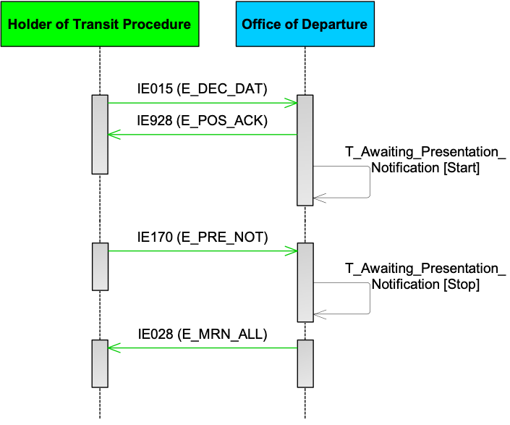
Figure 1: T-TRA-DEP-A-003-Transit presentation notification valid

T-TRA-DEP-A-002-Correction of the pre-lodged declaration prior to presentation of goods
Before the goods are presented and while the timer T_Await_Presentation_Notification is running, the Holder of the Transit is allowed to correct the transit declaration as many times, as they want. This scenario examines this case.
[Step 1] The Holder of the Transit Procedure submits the ‘Declaration Data’ E_DEC_DAT (IE015) message to the Office of Departure with ‘Additional Declaration Type’ to be equal to ‘D’.
[Step 2] The Office of Departure validates this message successfully (i.e. in terms of message structure and R/Cs) and sends the ‘Positive Acknowledge’ E_POS_ACK (IE928) message to the Holder of the Transit Procedure to acknowledge the reception of the transit declaration.
The state of the movement at the Office of Departure is set to Pre-Lodged.
[Step 3] The timer T_Await_Presentation_Notification starts. This timer sets the deadline by when the goods have to be presented to the Office of Departure.
[Step 4] The Holder of the Transit Procedure decides to correct the transit declaration and submits the ‘Declaration Amendment’ E_DEC_AMD (IE013) message.
[Step 5] Upon reception of the ‘Declaration Amendment’ E_DEC_AMD (IE013) message, the Office of Departure performs validation of the IE013 message in terms of structure and R/Cs. If the validation results are negative, the Office of Departure sends back the ‘Rejection from Office of Departure’ E_DEP_REJ (IE056) to the Holder of the Transit Procedure. If the validation results are positive, the Office of Departure sends back acceptance the ‘Amendment Acceptance’ E_AMD_ACC (IE004) message to the Holder of the Transit Procedure. The state of the movement at the Office of Departure remains Pre-Lodged."
NOTE: The 30-days timer T_Await_Presentation_Notification is not reset if the Holder of the Transit Procedure sends a correction to the transit declaration.
[Step 6] While the timer T_Await_Presentation_Notification is still running, the goods of the consignment are presented, and the Holder of the Transit Procedure notifies the Office of Departure of this fact by submitting the ‘Presentation Notification for the Pre-Lodged Declaration’ E_PRE_NOT (IE170) message to the Office of Departure.
The ‘Presentation Notification for the Pre-Lodged Declaration’ E_PRE_NOT (IE170) message is valid (i.e. in terms of message structure and R/Cs). In addition, based on the information contained in the ‘Presentation Notification for the Pre-Lodged Declaration’ E_PRE_NOT (IE170) message, the Office of Departure re-validates the Transit Declaration information (considering the ‘Declaration Data’ E_DEC_DAT (IE015) and any latest ‘Declaration Amendment’ E_DEC_AMD (IE013)) and ensures the validity of the reference data.
[Step 7] The timer T_Await_Presentation_Notification stops. In case the ‘Presentation Notification for the Pre-Lodged Declaration’ E_PRE_NOT (IE170) message is found invalid, this timer continues running.
[Step 8] Since all additional checks are successful, the state of the movement at the Office of Departure is set to Accepted. As a result, the MRN is communicated to the Holder of the Transit Procedure with the ‘MRN Allocated’ E_MRN_ALL (IE028) message.
NOTE: It shall be noted that if following the reception of the ‘Presentation Notification for the Pre-Lodged Declaration’ E_PRE_NOT (IE170) message, the re-validation of the Transit Declaration information (considering the ‘Declaration Data’ E_DEC_DAT (IE015) and any latest ‘Declaration Amendment’ E_DEC_AMD (IE013)) is unsuccessful (i.e. reference data are not valid), then the pre-lodged Transit Declaration is rejected. In such case, the Office of Departure sends to the Holder of the Transit Procedure a ‘Rejection from Office of Departure’ E_DEP_REJ (IE056) giving the reason for rejection. The state of the movement changes to Rejected, which is a final state and the scenario stops here. When a Transit Declaration has been rejected, the normal way of proceeding is the Holder of the Transit Procedure to send a new ‘Declaration Data’ E_DEC_DAT (IE015).
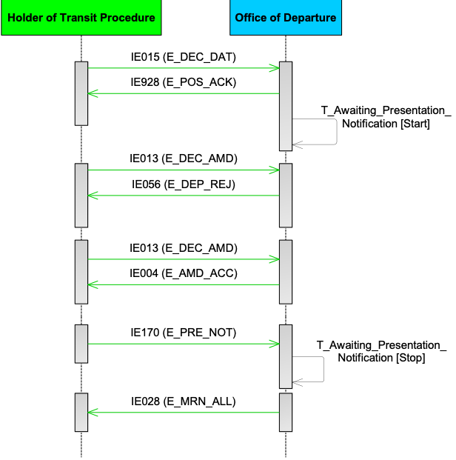
Figure 2: T-TRA-DEP-A-002-Correction of the pre-lodged declaration prior to presentation of goods

T-TRA-DEP-E-004-Transit presentation notification not valid
[Step 1] The Holder of the Transit Procedure submits the ‘Declaration Data’ E_DEC_DAT (IE015) message to the Office of Departure with ‘Additional Declaration Type’ to be equal to ‘D’.
[Step 2] The Office of Departure validates this message successfully (i.e. in terms of message structure and R/Cs) and sends the ‘Positive Acknowledge’ E_POS_ACK (IE928) message to the Holder of the Transit Procedure to acknowledge the reception of the transit declaration.
The state of the movement at the Office of Departure is set to Pre-Lodged.
[Step 3] The timer T_Await_Presentation_Notification starts. This timer sets the deadline by when the goods have to be presented to the Office of Departure.
[Step 4] While the timer T_Await_Presentation_Notification is running, the Holder of the Transit Procedure notifies the Office of Departure for the presentation of goods with the ‘Presentation Notification for the Pre-Lodged Declaration’ E_PRE_NOT (IE170) message.
[Step 5] However, the ‘Presentation Notification for the Pre-Lodged Declaration’ E_PRE_NOT (IE170) is invalid (i.e. in terms of message structure and R/Cs). Therefore, the Office of Departure rejects it by notifying back the Holder of the Transit Procedure with the ‘Rejection from Office of Departure’ E_DEP_REJ (IE056) message.
The Holder of the Transit Procedure however has the right to resend a valid ‘Presentation Notification for the Pre-Lodged Declaration’ E_PRE_NOT (IE170) message within the time limit of the thirty (30) days.
[Step 6] The timer T_Await_Presentation_Notification expires and no further ‘Presentation Notification for the Pre-Lodged Declaration’ E_PRE_NOT (IE170) is accepted afterwards.
[Step 7] In such a case, the Holder of the Transit Procedure is notified with the message ‘Rejection from Office of Departure’ E_DEP_REJ (IE056) by the Office of Departure meaning that the state of the movement is set to Rejected. This is a final state. The business flow of the transit procedure ends here.

Figure 3: T-TRA-DEP-E-004-Transit presentation notification not valid

T-TRA-DEP-E-005-Cancellation of the pre-lodged declaration prior to presentation of goods
For a pre-lodged transit declaration and before presenting the goods to the Office of Departure, and while the timer T_Await_Presentation_Notification is running, the Holder of the Transit Procedure is allowed to cancel the pre-lodged transit declaration. This scenario examines this case.
[Step 1] The Holder of the Transit Procedure submits the ‘Declaration Data’ E_DEC_DAT (IE015) message to the Office of Departure with ‘Additional Declaration Type’ to be equal to ‘D’.
[Step 2] The Office of Departure validates this message successfully (i.e. in terms of message structure and R/Cs) and sends the ‘Positive Acknowledge’ E_POS_ACK (IE928) message to the Holder of the Transit Procedure to acknowledge the reception of the transit declaration.
The state of the movement at the Office of Departure is set to Pre-Lodged.
[Step 3] The timer T_Await_Presentation_Notification starts. This timer sets the deadline by when the goods have to be presented to the Office of Departure.
[Step 4] The Holder of the Transit Procedure decides to cancel the pre-lodged declaration by sending the ‘Declaration Invalidation Request’ E_DEC_INV (IE014) message to the Office of Departure.
[Step 5] In case the ‘Declaration Invalidation Request’ E_DEC_INV (IE014) message is valid, the Office of Departure automatically sends a positive decision to cancel the pre-lodged declaration. The ‘Invalidation Decision’ E_INV_DEC (IE009) is sent to the Holder of the Transit Procedure. The state of the movement at the Office of Departure is set to Cancelled. This is a final state.
[Step 6] The timer T_Await_Presentation_Notification stops.
The business flow of the transit procedure ends here.
Figure 4: T-TRA-DEP-E-005-Cancellation of the pre-lodged declaration prior to presentation of goods

T-TRA-DEP-M-001-Normal procedure at departure
This scenario outlines the overview of the normal procedure at Departure.
[Step 1] The Holder of the Transit Procedure submits a transit declaration to the Office of Departure with the ‘Declaration Data’ E_DEC_DAT (IE015) message. The Office of Departure validates it and checks whether the transit declaration has been submitted under normal or simplified procedure. In this case, the movement is under normal procedure.
[Step 2] If the transit declaration is valid in terms of syntactic and semantic validations (i.e. checks in message structure and R/Cs), the Office of Departure acknowledges the reception of the transit declaration with the ‘Positive Acknowledge’ E_POS_ACK (IE928) message.
The state of the movement at the Office of Departure is set to Submitted.
[Step 3] The Office of Departure communicates the MRN to the Holder of the Transit Procedure with the ‘MRN Allocated’ E_MRN_ALL (IE028) message. The state of the movement at the Office of Departure is set to Accepted.
The Office of Departure may decide to control or not to control the movement. In this case the Office of Departure decides not to control the movement.
[Step 4] Office of Departure decide to release the movement. The state of the transit declaration at the Office of Departure is set to Movement released. The ‘Release for Transit’ E_REL_TRA (IE029) message is sent to Holder of the Transit Procedure.

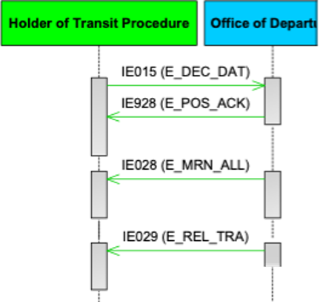
Figure 5: T-TRA-DEP-M-001-Normal procedure at departure

T-TRA-DEP-A-001-Simplified procedure at departure
The difference between normal and simplified procedure lies mainly in the type of location that the goods are placed at the Offices of Departure and Destination. In case of normal procedure, a Customs Officer has either direct access to the goods or at a designated/approved place, whereas in case of simplified procedure, the goods are placed at the premises of authorised consignor (at departure), or at the premises of the authorised consignee (at destination). A necessary precondition is that the Traders at Departure and Destination have received the necessary authorisations to perform the simplified procedure.
When a transit declaration is submitted under simplified procedure (i.e. the ‘Declaration Data’ E_DEC_DAT (IE015) message includes the Data Item <AUTHORISATION.Type> with the value ‘C521’ and the valid authorisation reference number), NTKS checks that the Holder of the Transit Procedure, who is responsible for the declaration, is indeed authorised to use simplified procedure at that Office of Departure.
NTKS also checks the authorised ‘Location of goods’ where an officer from the Office of Departure can control the consignment in case they decide to do that. When the Holder of Procedure uses seals, then NTKS checks them against the range of the seals numbers mentioned in the Authorisation.
After acceptance of the transit declaration following simplified procedure, a special timer is initiated for the movement to proceed automatically to the next step of the process, in case no control is decided until its expiration.
It should be noted that after acceptance of a transit declaration submitted under simplified procedure, the timer T_Awaiting_Automatic_Release is started to progress towards an automatic release of the transit after the timer has expired. We have the following cases:
- If the timer expires and no control decision has been taken by the Customs Officer, then the guarantee is registered, or
- While the timer is running, the Office of Departure takes the decision not to control, the guarantee is registered and the timer T_Awaiting_Automatic_Release stops, or
- While the timer is running, the Office of Departure takes the decision to control, then the movement will be controlled and the timer T_Awaiting_Automatic_Release stops.
[Step 1] The Holder of the Transit Procedure submits a transit declaration to the Office of Departure with the ‘Declaration Data’ E_DEC_DAT (IE015) message. The Office of Departure validates it and checks whether the transit declaration has been submitted under normal or simplified procedure. In this case, the movement is under simplified procedure.
[Step 2] If the transit declaration is valid in terms of syntactic and semantic validations (i.e. checks in message structure and R/Cs), the Office of Departure acknowledges the reception of the transit declaration with the ‘Positive Acknowledge’ E_POS_ACK (IE928) message.
The state of the movement at the Office of Departure is set to Submitted.
[Step 3] The Office of Departure communicates the MRN to the Holder of the Transit Procedure with the ‘MRN Allocated’ E_MRN_ALL (IE028) message. The state of the movement at the Office of Departure is set to Accepted.
[Step 4] Since the movement is under simplified procedure, the timer T_Awaiting_Automatic_Release starts.
During the execution of this timer, the Officer at Departure has the option to decide for control or not. When the timer expires, and no control has been decided, the movement proceeds to the guarantee registration process.
[Step 5] The timer T_Awaiting_Automatic_Release expires guarantees are registered and the Office of Departure decide to release the movement.
[Step 6] The state of the transit declaration at the Office of Departure is set to Movement released. The ‘Release for Transit’ E_REL_TRA (IE029) message is sent to Holder of the Transit Procedure.
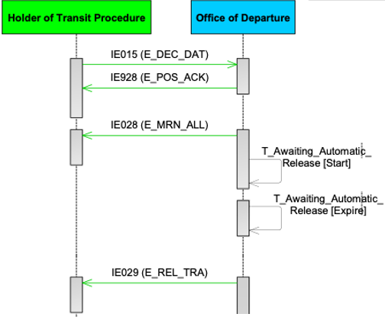
Figure 6: T-TRA-DEP-A-001-Simplified procedure at departure

T-TRA-DEP-E-012-Rejection of transit declaration
[Step 1] This scenario shows the case that the transit declaration, submitted by the Holder of the Transit Procedure to the Office of Departure with the ‘Declaration Data’ E_DEC_DAT (IE015) message, is rejected.
[Step 2] The Office of Departure validates the declaration data as invalid and thus rejects it by sending as response to the Holder of the Transit Procedure the ‘Rejection from Office of Departure’ E_DEP_REJ (IE056) message. The state of the movement at the Office of Departure is set to Rejected. This is a final state.
The business flow of the transit procedure ends here.
NOTE: This rejection may happen due to any of the following reasons:
- the ‘Declaration Data’ E_DEC_DAT (IE015) is found invalid in terms of Syntax and/or Rules and/or Conditions.
- the transit declaration has been submitted under simplified procedure, but:
  - the Holder of the Transit Procedure doesn’t have authorised consignor status, and/or has declared an invalid ‘Authorised location of goods’; and/or
  - the Holder of the Transit Procedure doesn’t have the authorisation to use of seals of a special type.
- the transit declaration has been submitted under normal procedure and the Customs Office of Departure does not approve the designated location of goods as declared in the declaration data.
- the timer Awaiting Presentation Notification expires (with thirty(30) days duration) and the goods have not been presented yet to the Office of Departure (i.e. no reception of ‘Presentation Notification for the Pre-Lodged Declaration’ E_PRE_NOT (IE170)).
- the transit declaration contains Export MRNs as previous references and at least one of the Export MRNs is invalid.

Figure 7: T-TRA-DEP-E-012-Rejection of transit declaration

Amendment of Transit Declaration
Amendments made by the Holder of the Transit Procedure enable changes to the declaration data right until the movement is released for transit. No amendment requests by the Holder of the Transit Procedure are allowed before the declaration is accepted and after it is released for transit. Moreover, amendment requests are rejected when movement is under control.
NOTE: Based on UCC, no amendments are allowed before the transit declaration is accepted. Therefore, prior to acceptance, the procedure is treated as ‘correction’ (T-TRA-DEP-A-002-Correction).
The amendment of the transit declaration as requested by the Holder of the Transit Procedure can cause the decision to control at Departure. This means that depending on the modifications, the Office of Departure may decide to perform control on the consignment, even though the amendment request has been accepted.
Several amendments can be sent before the movement is finally released (or not released) for Transit. There is, in principle, no limit to the number of amendments that can be sent. However, only one amendment request can be received at a time, meaning that the Office of Departure needs first to accept or reject the current amendment request before a new amendment request can be received. Otherwise, if there is a pending amendment request, while there is still no decision, any new incoming amendment request is automatically rejected.

T-TRA-DEP-A-014-Declaration amendment accepted
[Step 1] The Holder of the Transit Procedure submits a transit declaration to the Office of Departure with the ‘Declaration Data’ E_DEC_DAT (IE015) message. The Office of Departure validates it and checks whether the transit declaration has been submitted under normal or simplified procedure.
[Step 2] If the transit declaration is valid in terms of syntactic and semantic validations (i.e. checks in message structure and R/Cs), the Office of Departure acknowledges the reception of the transit declaration with the ‘Positive Acknowledge’ E_POS_ACK (IE928) message.
The state of the movement at the Office of Departure is set to Submitted.
[Step 3] The Office of Departure communicates the MRN to the Holder of the Transit Procedure with the ‘MRN Allocated’ E_MRN_ALL (IE028) message. The state of the movement at the Office of Departure is set to Accepted.
[Step 4] In case of simplified procedure, the timer T_Awaiting_Automatic_Release at the Office of Departure starts.
[Step 5] The Holder of the Transit Procedure notifies the Office of Departure of needed changes to the original declaration with a valid ‘Declaration Amendment’ E_DEC_AMD (IE013) before the goods have been released for transit. It should be noted that the timer T_Awaiting_Automatic_Release is not affected (i.e. continues to run) when an amendment request is received (i.e. under Simplified Procedure).
[Step 6] The amendment request is valid in terms of message structure and R/Cs. Therefore, the Office of Departure notifies the Holder of the Transit Procedure about the acceptance of the amendment with the ‘Amendment Acceptance’ E_AMD_ACC (IE004) message. The state of the movement at the Office of Departure remains Accepted.
After the ‘Declaration Amendment’ is accepted the Customs Officer can decide to control or not to control the consignment.
[Step 7] In case the timer T_Awaiting_Automatic_Release at the Office of Departure is already running, then it restarts.
Figure 8: T-TRA-DEP-A-014-Declaration amendment accepted

T-TRA-DEP-E-015-Declaration amendment rejected
[Step 1] The Holder of the Transit Procedure submits a transit declaration to the Office of Departure with the ‘Declaration Data’ E_DEC_DAT (IE015) message. The Office of Departure validates it and checks whether the transit declaration has been submitted under normal or simplified procedure.
[Step 2] If the transit declaration is valid in terms of syntactic and semantic validations (i.e. checks in message structure and R/Cs), the Office of Departure acknowledges the reception of the transit declaration with the ‘Positive Acknowledge’ E_POS_ACK (IE928) message.
The state of the movement at the Office of Departure is set to Submitted.
[Step 3] The Office of Departure communicates the MRN to the Holder of the Transit Procedure with the ‘MRN Allocated’ E_MRN_ALL (IE028) message. The state of the movement at the Office of Departure is set to Accepted.
[Step 4] In case of simplified procedure, the timer T_Awaiting_Automatic_Release at the Office of Departure starts.
[Step 5] An invalid ‘Declaration Amendment’ E_DEC_AMD (IE013) message is sent by the Holder of the Transit Procedure (i.e. invalid in terms of message structure and/or R/Cs). It should be noted that the timer T_Awaiting_Automatic_Release is not affected (i.e. continues to run) when an amendment request is received (i.e. under Simplified Procedure).
[Step 6] The ‘Rejection from Office of Departure’ E_DEP_REJ (IE056) message is sent automatically to the Holder of the Transit Procedure to notify about the rejection of the amendment request.
When the amendment request is rejected, there is no change in the previous version of the declaration data.
NOTE: The amendment request submitted by the Holder of Transit is automatically validated (i.e. no human intervention is needed). Therefore, the declaration amendment request shall be rejected for any of the following reasons:
- The ‘Declaration Amendment’ E_DEC_AMD (IE013) message is invalid (failure of the syntactic or semantic validation);
- The ‘Declaration Amendment’ E_DEC_AMD (IE013) message is (possibly) valid but received in an inappropriate state.

In both cases, the ‘Rejection from Office of Departure’ E_DEP_REJ (IE056) message is automatically sent back to the Holder of the Transit Procedure and the state of the movement remains unchanged (i.e. the previous declaration data remains applicable).
Figure 9: T-TRA-DEP-E-015-Declaration amendment rejected

T-TRA-DEP-M-006-Control by Office of Departure with release for transit
[Step 1] The Holder of the Transit Procedure submits a transit declaration to the Office of Departure with the ‘Declaration Data’ E_DEC_DAT (IE015) message. The Office of Departure validates it and checks whether the transit declaration has been submitted under normal or simplified procedure.
[Step 2] If the transit declaration is valid in terms of syntactic and semantic validations (i.e. checks in message structure and R/Cs), the Office of Departure acknowledges the reception of the transit declaration with the ‘Positive Acknowledge’ E_POS_ACK (IE928) message.
The state of the movement at the Office of Departure is set to Submitted.
[Step 3] The Office of Departure communicates the MRN to the Holder of the Transit Procedure with the ‘MRN Allocated’ E_MRN_ALL (IE028) message. The state of the movement at the Office of Departure is set to Accepted.
[Step 4] In case of simplified procedure, the timer T_Awaiting_Automatic_Release at the Office of Departure starts.
[Step 5] The Office of Departure decides to control the transit movement and as a result the timer T_Awaiting_Automatic_Release stops (i.e. if it has been previously initiated due to Simplified Procedure).
[Step 6] If movement is under normal procedure, the Office of Departure sends the ‘Control Decision Notification’ E_CTR_DEC (IE060) message to the Holder of the Transit Procedure to notify about the upcoming control activities (having the data element TRANSIT OPERATION-Notification type = ‘0-Decision to Control (and requested documents if needed)’)
[Step 7] The Office of Departure completes control and finds no discrepancies and does not identify that the goods pose a threat to the safety and security.
[Step 8] Office of Departure decide to release the movement. The state of the transit declaration at the Office of Departure is set to Movement released. The ‘Release for Transit’ E_REL_TRA (IE029) message is sent to Holder of the Transit Procedure.

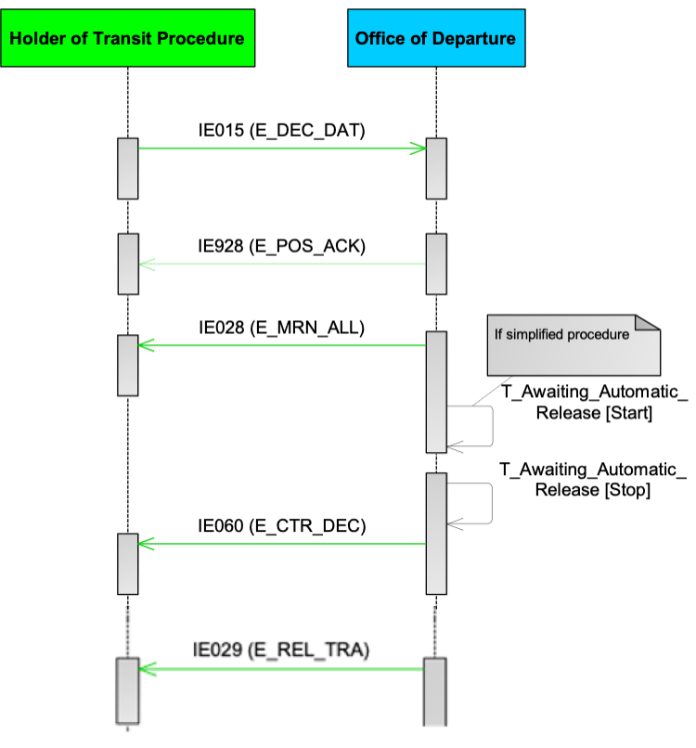
Figure 10: T-TRA-DEP-M-006-Control by Office of Departure with release for transit

Movement is not released for Transit

T-TRA-DEP-A-010-Control by Office of Departure with release for transit refused
This section elaborates the case that the Office of Departure does not release the goods for transit after control under normal or simplified procedure.
[Step 1] The Holder of the Transit Procedure submits a transit declaration to the Office of Departure with the ‘Declaration Data’ E_DEC_DAT (IE015) message. The Office of Departure validates it and checks whether the transit declaration has been submitted under normal or simplified procedure.
[Step 2] If the transit declaration is valid in terms of syntactic and semantic validations (i.e. checks in message structure and R/Cs), the Office of Departure acknowledges the reception of the transit declaration with the ‘Positive Acknowledge’ E_POS_ACK (IE928) message.
The state of the movement at the Office of Departure is set to Submitted.
[Step 3] The Office of Departure communicates the MRN to the Holder of the Transit Procedure with the ‘MRN Allocated’ E_MRN_ALL (IE028) message. The state of the movement at the Office of Departure is set to Accepted.
[Step 4] In case of simplified procedure, the timer T_Awaiting_Automatic_Release at the Office of Departure starts.
[Step 5] The Office of Departure decides to control the transit movement and as a result the timer T_Awaiting_Automatic_Release stops (i.e. if it has been previously initiated due to Simplified Procedure).
[Step 6] if movement is under normal procedure, the Office of Departure sends the ‘Control Decision Notification’ E_CTR_DEC (IE060) message to the Holder of the Transit Procedure to notify about the upcoming control activities (having the data element TRANSIT OPERATION-Notification type = ‘0-Decision to Control (and requested documents if needed)’)
[Step 7] The Office of Departure completes control and finds either major discrepancies or identifies that the goods pose a threat to the safety and security. Therefore, the Office of Departure decides that the consignment cannot be released for transit.
[Step 8] The Office of Departure informs the Holder of the Transit Procedure by sending the ‘No Release for Transit’ E_REL_NOT (IE051) message. The state of the transit operation is set to Not released for Transit. This is a final state.
The business flow of the transit procedure ends here.
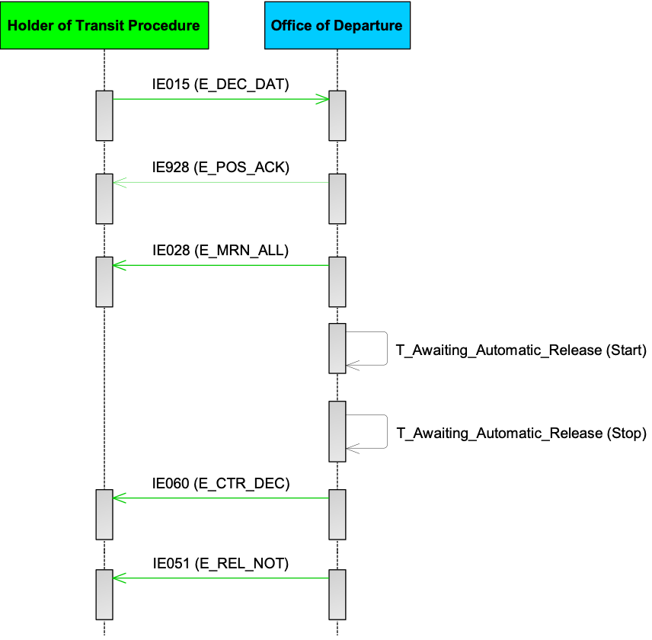
Figure 11: T-TRA-DEP-A-010-Control by Office of Departure with release for transit refused

T-TRA-DEP-A-046-Request for additional documents during control
This scenario describes the case when the Office of Departure decides to request for additional document(s) from the Holder of the Transit Procedure during control. Office of Departure may request for additional document(s) multiple times.
[Step 1] The Holder of the Transit Procedure submits a transit declaration to the Office of Departure with the ‘Declaration Data’ E_DEC_DAT (IE015) message. The Office of Departure validates it and checks whether the transit declaration has been submitted under normal or simplified procedure.
[Step 2] If the transit declaration is valid in terms of syntactic and semantic validations (i.e. checks in message structure and R/Cs), the Office of Departure acknowledges the reception of the transit declaration with the ‘Positive Acknowledge’ E_POS_ACK (IE928) message.
The state of the movement at the Office of Departure is set to Submitted.
[Step 3] The Office of Departure communicates the MRN to the Holder of the Transit Procedure with the ‘MRN Allocated’ E_MRN_ALL (IE028) message. The state of the movement at the Office of Departure is set to Accepted.
[Step 4] In case of simplified procedure, the timer T_Awaiting_Automatic_Release at the Office of Departure starts.
[Step 5] The Office of Departure decides to control the transit movement and as a result the timer T_Awaiting_Automatic_Release stops (i.e. if it has been previously initiated due to Simplified Procedure).
[Step 6] If movement is under normal procedure, the Office of Departure sends the ‘Control Decision Notification’ E_CTR_DEC (IE060) message to the Holder of the Transit Procedure to notify about the upcoming control activities (having the data element TRANSIT OPERATION-Notification type = ‘0-Decision to Control (and requested documents if needed)’).
[Step 7] The Office of Departure proceeds to control and finds that additional document(s) are required from the Holder of the Transit Procedure. The Office of Departure sends the ‘Control Decision Notification’ E_CTR_DEC (IE060) message to the Holder of the Transit Procedure to request for additional document(s) (having the data element TRANSIT OPERATION-Notification type = ‘1-Additional documents request’).
[Step 8] The Holder of the Transit Procedure responds with the ‘Response to the Requested Documents’ E_CTR_DEC (IE046) message with the additional documents requested.
[Step 9] The Office of Departure may require more additional document(s) during control and may send another ‘Control Decision Notification’ E_CTR_DEC (IE060) message to the Holder of the Transit Procedure to request for additional document(s) (having the data element TRANSIT OPERATION-Notification type = ‘1-Additional documents request’).
[Step 10] The Holder of the Transit Procedure responds with the ‘Response to the Requested Documents’ E_CTR_DEC (IE046) message with the additional documents requested.
[Step 11] Office of Departure decide to release the movement. The state of the transit declaration at the Office of Departure is set to Movement released. The ‘Release for Transit’ E_REL_TRA (IE029) message is sent to Holder of the Transit Procedure.
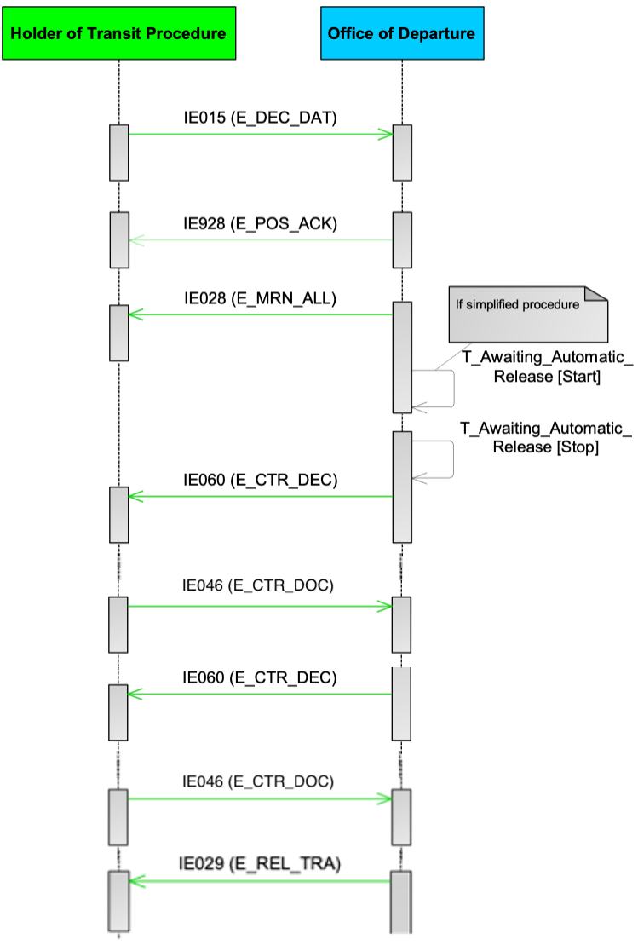
Figure 12: T-TRA-DEP-A-046-Request for additional documents during control

T-TRA-DEP-A-013-Release for transit refused due to guarantee registration failure
[Step 1] The Holder of the Transit Procedure submits a transit declaration to the Office of Departure with the ‘Declaration Data’ E_DEC_DAT (IE015) message. The Office of Departure validates it and checks whether the transit declaration has been submitted under normal or simplified procedure.
[Step 2] If the transit declaration is valid in terms of syntactic and semantic validations (i.e. checks in message structure and R/Cs), the Office of Departure acknowledges the reception of the transit declaration with the ‘Positive Acknowledge’ E_POS_ACK (IE928) message.
The state of the movement at the Office of Departure is set to Submitted.
[Step 3] The Office of Departure communicates the MRN to the Holder of the Transit Procedure with the ‘MRN Allocated’ E_MRN_ALL (IE028) message. The state of the movement at the Office of Departure is set to Accepted.
In case of simplified procedure, the timer T_Awaiting_Automatic_Release at the Office of Departure starts.
[Step 4] The Office of Departure may decide to control or not to control the movement. In this case the Office of Departure decides not to control the movement.
[Step 5] Guarantee registration is not successful. The timer at the Office of Departure T_Guarantee_Awaiting_Amendment starts. The state of the movement at the Office of Departure is set to Guarantee under amendment.
[Step 6] The Holder of the Transit Procedure is notified with the ‘Guarantee Not Valid’ E_GUA_INV (IE055) message since the declared guarantee is not valid.
[Step 7] After reception of the ‘Guarantee Not Valid’ E_GUA_INV (IE055) message, the Holder of the Transit Procedure needs to amend the invalid guarantee by sending the ‘Declaration Amendment’ E_DEC_AMD (IE013) message.
[Step 8] If the Holder of the Transit Procedure sends no ‘Declaration Amendment’ E_DEC_AMD (IE013) until when the timer T_Guarantee_Awaiting_Amendment at the Office of Departure expires the movement is not released for transit and the ‘No Release for Transit’ E_REL_NOT (IE051) message is sent to the Holder of the Transit Procedure.
The state of the movement at the Office of Departure is set to Not released for Transit. This is a final state.
The business flow of the transit operation ends here.
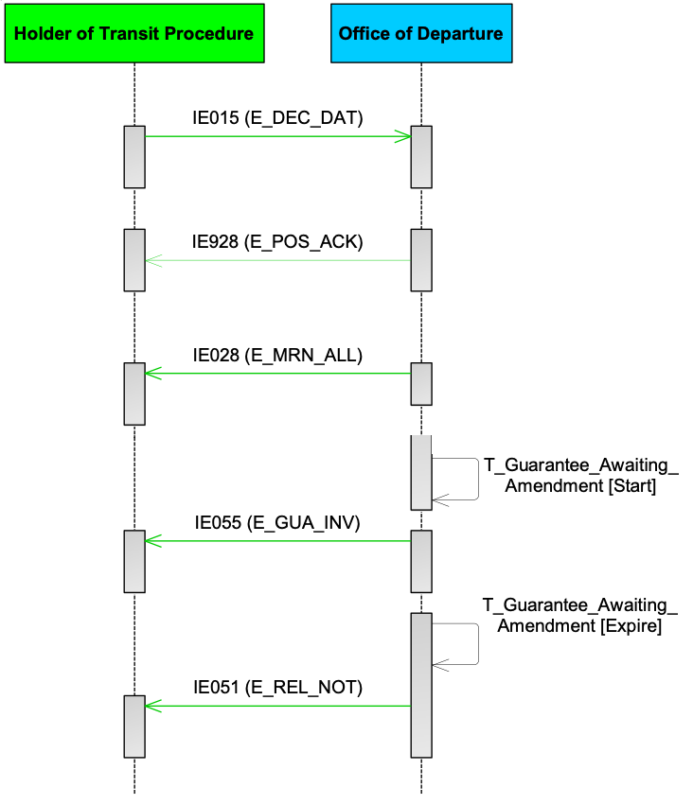
Figure 13: T-TRA-DEP-A-013-Release for transit refused due to guarantee registration failure

Invalidation of Transit Declaration
An already accepted transit declaration (i.e. after state Accepted) can be invalidated by the Holder of the Transit Procedure via the ‘Declaration Invalidation Request’ E_DEC_INV (IE014) message, but only before release for transit (i.e. before state Movement released). Upon reception of the ‘Declaration Invalidation Request’ E_DEC_INV (IE014) message, the Office of Departure examines the request and informs the Holder of the Transit Procedure accordingly of the result of such request via the ‘Invalidation Decision’ E_INV_DEC (IE009) message (i.e. positive or negative). However, where the Office of Departure has informed the Holder of the Transit Procedure of its intention to examine the goods with the ‘Control decision notification’ E_CTR_DEC (IE060) message (having the data element TRANSIT OPERATION-Notification type = ‘0-Decision to Control (and requested documents if needed)’), a request for invalidation of the customs declaration will be automatically rejected.
Invalidation of the declaration can be performed under one (1) of the following conditions:
- The Holder of the Transit Procedure can electronically request invalidation of an accepted transit declaration before the goods are released for transit, except when the movement is under control by Customs.
- The Holder of the Transit Procedure can request from the Office of Departure to invalidate the transit declaration after the goods are released for transit only in two (2) specific cases:
  - Union goods have been declared in error for a transit procedure applicable only to non-Union goods, or
  - Goods have been erroneously declared under more than one (1) transit declaration.
However, after release for transit, this invalidation request cannot be requested via the ‘Declaration Invalidation Request’ E_DEC_INV (IE014) message; In this case, the invalidation request can be requested by the Holder of the Transit Procedure from the Office of Departure outside the system; However, the movement cannot be invalidated when it has already passed from one (1) or more involved Offices and/or has arrived at its final destination.
After invalidation, no further actions are possible for the transit movement at the Office of Departure or the Office of Destination.

T-TRA-DEP-A-016-Invalidation request by the Holder of the Transit Procedure before release for transit
This is the simplest case of invalidation.
[Step 1] The Holder of the Transit Procedure submits a transit declaration to the Office of Departure with the ‘Declaration Data’ E_DEC_DAT (IE015) message. The Office of Departure validates it and checks whether the transit declaration has been submitted under normal or simplified procedure.
[Step 2] If the transit declaration is valid in terms of syntactic and semantic validations (i.e. checks in message structure and R/Cs), the Office of Departure acknowledges the reception of the transit declaration with the ‘Positive Acknowledge’ E_POS_ACK (IE928) message.
The state of the movement at the Office of Departure is set to Submitted.
[Step 3] The Office of Departure communicates the MRN to the Holder of the Transit Procedure with the ‘MRN Allocated’ E_MRN_ALL (IE028) message. The state of the movement at the Office of Departure is set to Accepted.
[Step 4] the Holder of the Transit Procedure decides to invalidate the transit declaration and therefore notifies the Office of Departure with the ‘Declaration Invalidation Request’ E_DEC_INV (IE014) message. The state of the movement at the Office of Departure remains unchanged.
The invalidation decision by the Customs Officer at the Office of Departure can be positive or negative (“Decision” is set to “1=Yes” when it is positive or to “0=No” when it is negative). This decision is communicated to the Holder of the Transit Procedure with the same message ‘Invalidation Decision’ E_INV_DEC (IE009) [If the “Decision” is set to “1=Yes”, the state of the movement at the Office of Departure is set to Invalidated, but if the “Decision” is set to “0=No”, the state of the movement at the Office of Departure remains unchanged].
[Step 5] The Office of Departure examines the request and replies with the positive decision with the ‘Invalidation Decision’ E_INV_DEC (IE009) message (i.e. “Decision” is set to “1=Yes”).
The state of the movement at the Office of Departure is set to Invalidated. This is a final state.
The business flow of the transit operation ends here.
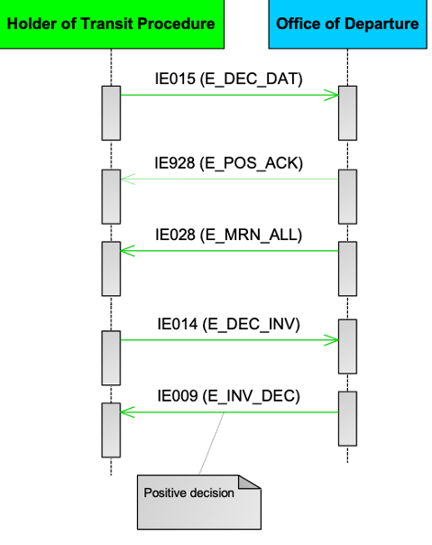
Figure 14: T-TRA-DEP-A-016-Invalidation request by the Holder of the Transit Procedure before release for transit – Accepted
In another case, when the negative decision is communicated with the ‘Invalidation Decision’ E_INV_DEC (IE009) message (“Decision” is set to “0=No”), the movement is not invalidated and continues normally.
Figure 15: T-TRA-DEP-A-016-Invalidation request by the Holder of the Transit Procedure before release for transit – Rejected

T-TRA-DEP-A-017-Invalidation request by the Holder of the Transit Procedure after release for transit
[Step 1] The Holder of the Transit Procedure submits a transit declaration to the Office of Departure with the ‘Declaration Data’ E_DEC_DAT (IE015) message. The Office of Departure validates it and checks whether the transit declaration has been submitted under normal or simplified procedure.
[Step 2] If the transit declaration is valid in terms of syntactic and semantic validations (i.e. checks in message structure and R/Cs), the Office of Departure acknowledges the reception of the transit declaration with the ‘Positive Acknowledge’ E_POS_ACK (IE928) message.
The state of the movement at the Office of Departure is set to Submitted.
[Step 3] The Office of Departure communicates the MRN to the Holder of the Transit Procedure with the ‘MRN Allocated’ E_MRN_ALL (IE028) message. The state of the movement at the Office of Departure is set to Accepted.
The Office of Departure decide not to control and to release the movement.
[Step 4] The state of the transit declaration at the Office of Departure is set to Movement released. The ‘Release for Transit’ E_REL_TRA (IE029) message is sent to Holder of the Transit Procedure.
[Step 5] The Holder of the Transit Procedure sends the ‘Declaration Invalidation Request’ E_DEC_INV (IE014) message. The state of the movement at the Office of Departure is Movement released.
[Step 6] The Holder of the Transit Procedure is not allowed to request invalidation of the transit declaration after release for transit. The Office of Departure automatically rejects the ‘Declaration Invalidation Request’ E_DEC_INV (IE014) by notifying the Holder of the Transit Procedure with the ‘Rejection from Office of Departure’ E_DEP_REJ (IE056) message. The state of the movement at the Office of Departure remains unchanged.
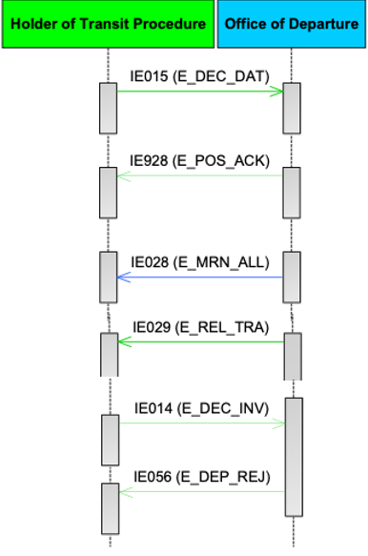
Figure 16: T-TRA-DEP-A-017-Invalidation request by the Holder of the Transit Procedure after release for transit

Specific Scenarios at Office of Transit (TRT)

T-TRA-TRT-A-003-Arrival at Office of Transit with Passage Confirmed
Following the presentation of the goods by Holder of the Transit Procedure, the Office of Transit retrieves the movement information via MRN and assesses that the goods shall cross the border of this Office of Transit.
[Step 1] Upon arrival at the Office of Transit, the Holder of the Transit Procedure sends the ‘Presentation Notification at Office of Transit’ E_TRA_PRE_NOT (IE117), which signifies the presentation of goods to customs. The state of the transit movement at the Office of Transit is set to Arrival accepted at the Office of Transit.
In case an invalid ‘Presentation Notification at Office of Transit’ E_TRA_PRE_NOT (IE117) message (i.e. in terms of syntax and R/Cs), the Office of Transit will reject it with the ‘Rejection from Office of Transit’ E_TRA_REJ (IE058) message. The state of the transit movement at Office of Transit remains unchanged.
[Step 2] At this Office of Transit the passage is confirmed. In that case, the state of the transit operation at the Office of Transit is set to NCF Registered.
Upon completion of the above steps, the business flow of this transit procedure ends here.

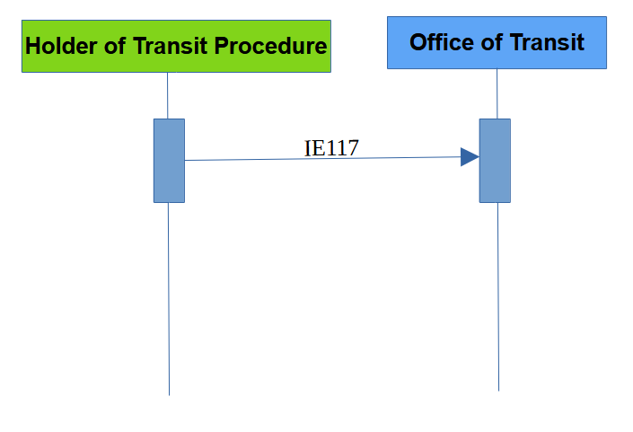
Figure 17: Arrival Notification by the Holder of the Transit Procedure at the Customs Office of Transit

T-TRA-TRT-A-004-Arrival at Office of Transit with Passage Not Confirmed
This scenario describes what happens when the carrier of the consignment arrives at the Office of Transit and after the Office of Transit retrieves the movement information via the MRN, it is assesses that the goods shall not cross the border of this Office of Transit. In that case, the movement is stopped as per scenario, and the Office of Transit becomes Actual Office of Destination.
[Step 1] Upon arrival at the Office of Transit, the Holder of the Transit Procedure sends the ‘Presentation Notification at Office of Transit’ E_TRA_PRE_NOT (IE117), which signifies the presentation of goods to customs. The state of the transit movement at the Office of Transit is set to Arrival accepted at the Office of Transit.
In case an invalid ‘Presentation Notification at Office of Transit’ E_TRA_PRE_NOT (IE117) message (i.e. in terms of syntax and R/Cs), the Office of Transit will reject it with the ‘Rejection from Office of Transit’ E_TRA_REJ (IE058) message. The state of the transit movement at Office of Transit remains unchanged.
[Step 2] The Office of Transit decides to stop the movement. The state at the Office of Transit is set to Movement Stopped.
Upon completion of the above steps, the business flow of this transit procedure at Office of Transit ends, and the business flow at Office of Destination starts.

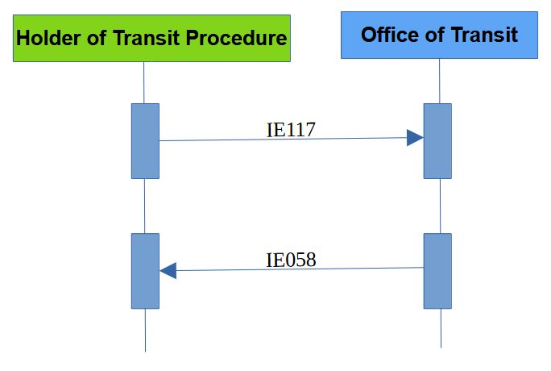
Figure 18: Arrival Notification by the Holder of the Transit Procedure at the Customs Office of Transit - Invalidated

Specific Scenarios at Office of Destination (DES)
The consignment arrives at the Office of Destination at a designated or approved place. However, if the consignment is under the responsibility of an authorised consignee, the goods arrive at the authorised place. Arrival is announced by the Trader at Destination (authorised consignee in case of simplified procedure). After arrival is accepted by the Office of Destination, the business flow of the transit operation continues with the control procedure at the Office of Destination by taking into consideration one (1) of the following possibilities:
- Normal procedure at the Office of Destination with no control or control with satisfactory control results; or
- Simplified procedure at the Office of Destination; or
- Control with unsatisfactory control results at the Office of Destination.

T-TRA-DES-M-001-Arrival notification valid under normal procedure with no control or control with satisfactory control results
[Step 1] When the consignment reaches its destination and operates under normal procedure, the Trader at Destination sends the ‘Arrival Notification’ E_ARR_NOT (IE007) to the Office of Destination. NTKS performs validation of this message. If it is valid in terms of message structure and R/Cs, the Office of Destination checks whether the movement information is available.
Upon reception of the valid ‘Arrival Notification’ E_ARR_NOT (IE007) message, the state of the movement at the Office of Destination is set to Arrival accepted. The state of the movement at the Office of Departure is set to Arrived.
The Customs Officer at Destination decides not to control the movement or controls the movement and enters satisfactory control results.
[Step 2] The goods are released from transit. The Office of Destination sends the ‘Goods Released Notification’ E_GDS_REL (IE025) message to the Trader at Destination (i.e. “Release Indicator” flag is equal to “1-Full release of goods (as per declaration) - Movement closed”).
The state of the movement at the Office of Destination is set to Goods released.
The state of the movement at the Office of Departure is set to Movement written off.
[Step 3] The Office of Departure sends the ‘Write-Off Notification’ E_WRT_NOT (IE045) message to the Holder of the Transit Procedure.
Upon completion of the above steps, the business flow of this transit procedure ends here.

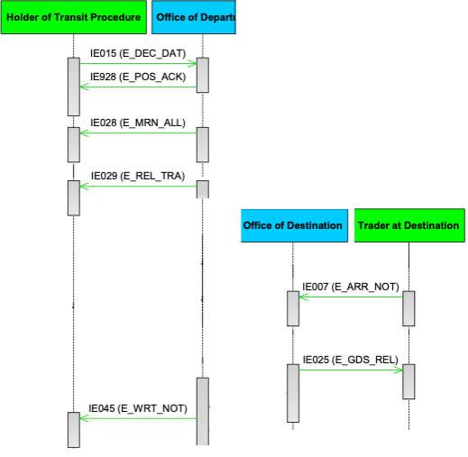
Figure 19: T-TRA-DES-M-001-Arrival notification valid under normal procedure with no control or control with satisfactory control results

T-TRA-DES-A-004-Simplified procedure at destination
[Step 1] When the Trader at Destination sends the ‘Arrival Notification’ E_ARR_NOT (IE007) message under simplified procedure (simplified procedure flag = ‘Yes’), NTKS checks that the Trader at Destination is indeed authorised (i.e. Authorised Consignee) to use simplified procedure at that Office of Destination. Specifically, NTKS checks the TIN number against the Authorisation number. NTKS also checks that the location where the consignment can be controlled is amongst the various authorised places at the particular Office of Destination specified in the Authorisation. ‘Arrival Notification’ E_ARR_NOT (IE007) message is validated (i.e. in terms of message structure and R/Cs). If it is valid in terms of message structure and R/Cs, the Office of Destination checks whether the movement information is available.
[Step 2] Since it is simplified procedure, the T_Wait_Unloading_Permission timer at the Office of Destination starts.
[Step 3] Upon reception of the valid ‘Arrival Notification’ E_ARR_NOT (IE007) message, the state of the movement at the Office of Destination is set to Arrival accepted. The state of the movement at the Office of Departure is set to Arrived.
[Step 4] The timer at the Office of Destination T_Wait_Unloading_Permission expires.
[Step 5] Since the Office of Destination did not decide to control the consignment, while the T_Wait_Unloading_Permission timer was running, the Office of Destination notifies the Trader at Destination that the unloading of the goods can be started by means of ‘Unloading Permission’ E_ULD_PER (IE043).
The state of the movement at the Office of Destination is set to Unloading.
[Step 6] After unloading, the Trader at Destination sends the ‘Unloading Remarks’ E_ULD_REM (IE044) to the Office of Destination indicating that the unloading has been completed with no unloading remarks (i.e. the ‘Unloading Remarks’ E_ULD_REM (IE044) message contains the flags Unloading completion = ‘1-Yes’ & Conform = ‘1-Yes’).
[Step 7] The goods are released from transit. The Office of Destination sends the ‘Goods Released Notification’ E_GDS_REL (IE025) message to the Trader at Destination (i.e. “Release Indicator” flag is equal to “1-Full release of goods (as per declaration) - Movement closed”).
The state of the movement at the Office of Destination is set to Goods released.
The state of the movement at the Office of Departure is set to Movement written off.
[Step 8] The Office of Departure sends the ‘Write-Off Notification’ E_WRT_NOT (IE045) message to the Holder of the Transit Procedure.
Upon completion of the above steps, the business flow of this transit procedure ends here.

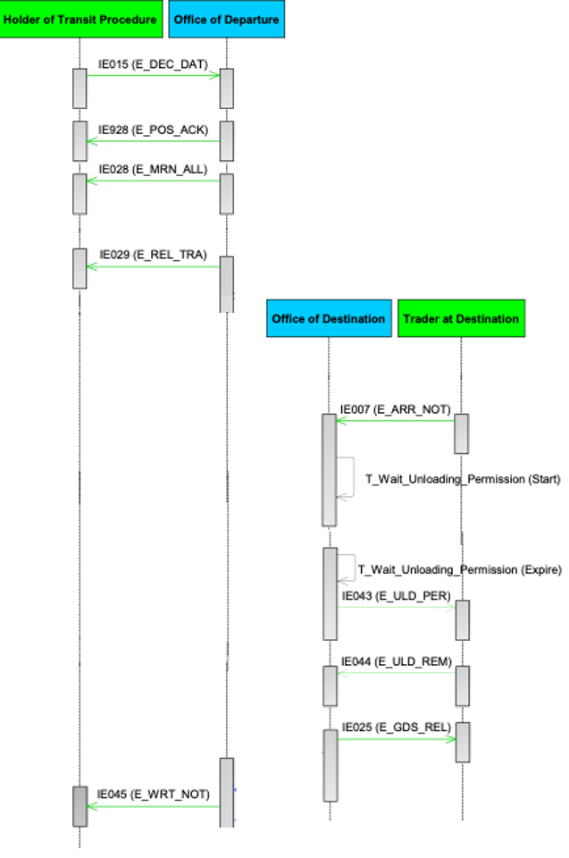
Figure 20: T-TRA-DES-A-004-Simplified procedure at destination

T-TRA-DES-A-006-Unloading Permission Received – Unloading Remarks
When the timer Waiting for Automatic Unloading expires, it means that the Office of Destination decides no control and that the authorised consignee can start unloading the goods. So, upon its expiration, the ‘Unloading Permission’ E_ULD_PER (IE043) message is automatically sent to the authorised consignee to allow him/her the unloading at the authorised place. Under no circumstances, the authorised consignee can start the unloading of the goods at the authorised place before the reception of the ‘Unloading Permission’ E_ULD_PER (IE043) message.
When the authorised consignee completes the unloading or because he/she just likes to inform the Office of Destination about the status of the unloading, he/she sends the ‘Unloading Remarks’ E_ULD_REM (IE044) message to the Office of Destination, which contains the following data elements:
- The data element ‘Conform’ indicates the presence / no presence of Unloading Remarks;
- The data element ‘State of Seals ok’ provides information about the state of the seals (i.e. empty value in the data element means that the state of seals is in good condition);
- The data element ‘Unloading completion’ indicates whether unloading is completed or not.
Based on the above, we have the following possibilities after the Office of Destination receives the ‘Unloading Remarks’ E_ULD_REM (IE044) message from the authorised consignee:
- If unloading is completed (i.e. Unloading completion = ‘1-Yes), the state of seals is in good condition (i.e. State of seals = ‘1-Yes’) and we have no presence of Unloading Remarks (i.e. Conform flag = ‘1-Yes’), then the Office of Destination continues processing; or
- If unloading is completed (i.e. Unloading completion = ‘1-Yes), the state of seals is in good condition (i.e. State of seals = ‘1-Yes’) but we have presence of Unloading Remarks (i.e. Conform flag = ‘0-No’), then the Office of Destination needs to decide whether to control or not the transit movement; or
- In all other cases that there are unloading remarks (i.e. Conform flag = ‘0-No’) and/or the state of seals is not in good condition (i.e. State of seals = ‘0-No’) and/or the unloading is not completed (i.e. Unloading completion = ‘0-No’), the Office of Destination needs to decide whether to control or not the transit movement. In case “no control” is decided, the Office of Destination sends a new ‘Unloading Permission’ E_ULD_PER (IE043) message, and the state of the transit movement is set to Unloading.
For the above possibility A was already covered in the previous section.
This scenario examines the other two (2) possibilities (i.e. B and C) where the Office of Destination needs to decide about control of the transit movement based on the unloading remarks received from the authorised consignee.
[Step 1] Upon arrival of the movement at the Office of Destination, the Trader at Destination announces it by submitting the ‘Arrival Notification’ E_ARR_NOT (IE007) message.
Provided that the message is valid, the Office of Destination checks whether the arrival notification has been submitted under normal or simplified procedure. In this case, the movement is under simplified procedure.
[Step 2] Since it is simplified procedure, the T_Wait_Unloading_Permission timer at the Office of Destination starts.
[Step 3] The timer at the Office of Destination T_Wait_Unloading_Permission expires.
[Step 4] Since the Office of Destination did not provide into the system the decision to control the consignment, while the T_Wait_Unloading_Permission timer was running, the Office of Destination then notifies the authorised consignee that the unloading of the goods can be started by means of the ‘Unloading Permission’ E_ULD_PER (IE043) message.
The state of the movement at the Office of Destination is set to Unloading.
[Step 5] The authorised consignee sends the ‘Unloading Remarks’ E_ULD_REM (IE044) message to the Office of Destination indicating either the discovery of irregularities into the transit movement and/or non-completion of the unloading of the goods (i.e. please refer to the possibilities B and C above).
The state of the movement is set to Unloading Remarks.
The Office of Destination has either to decide whether to control the transit movement or not to control the transit movement and allow the unloading in case it is indicated in the received ‘Unloading Remarks’ E_ULD_REM (IE044) message that the unloaded was not yet completed (i.e. Unloading completion = ‘0-No’).
The business flow of the transit procedure at the Office of Destination continues with any of the following alternatives:
- Control decision (i.e. with / without unloading remarks) or control after unloading remarks with satisfactory control results; or
- Control after unloading remarks with unsatisfactory control results at the Office of Destination; or
- Unloading is not completed, and the Office of Destination decides no control and allows the authorised consignee to continue the unloading, the business flow of the transit operation continues by the Office of Destination sending a new ‘Unloading Permission’ E_ULD_PER (IE043) message to the authorised consignee.

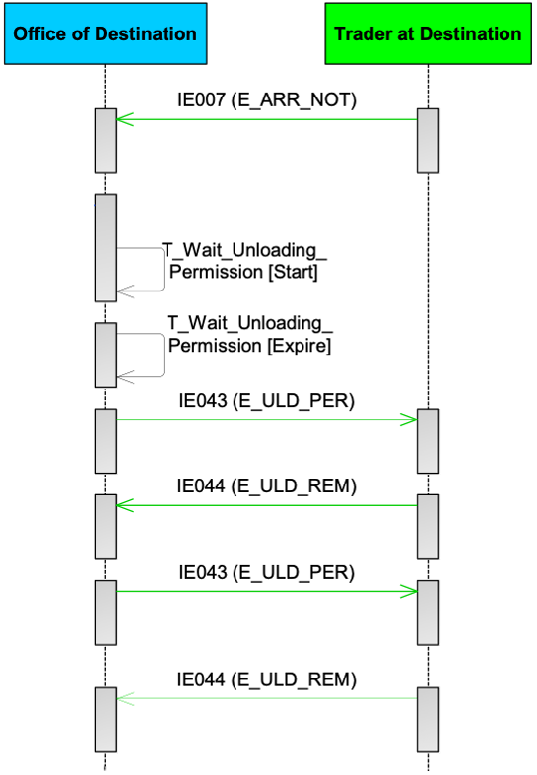
Figure 21: T-TRA-DES-A-006-Unloading permission received–unloading remarks

T-TRA-DES-E-007-Unloading remarks rejected
This scenario applies to simplified procedure only and describes what happens when the Office of Destination rejects the invalid ‘Unloading Remarks’ E_ULD_REM (IE044) message (i.e. in terms of structure and R/Cs) received by the authorised consignee.
[Step 1] Upon arrival of the movement at the Office of Destination, the Trader at Destination announces it by submitting the ‘Arrival Notification’ E_ARR_NOT (IE007) message.
Provided that the message is valid, the Office of Destination checks whether the arrival notification has been submitted under normal or simplified procedure. In this case, the movement is under simplified procedure.
[Step 2] Since it is simplified procedure, the T_Wait_Unloading_Permission timer at the Office of Destination starts.
[Step 3] Since the Office of Destination did not provide into the system the decision to control the consignment, while the T_Wait_Unloading_Permission timer was running, the Office of Destination then notifies the Trader at Destination that the unloading of the goods can be started by means of ‘Unloading Permission’ E_ULD_PER (IE043).
The state of the movement at the Office of Destination is set to Unloading.
[Step 4] After unloading, the Trader at Destination sends an invalid ‘Unloading Remarks’ E_ULD_REM (IE044) message to the Office of Destination.
[Step 5] The Office of Destination rejects these remarks by sending back a ‘Rejection from Office of Destination’ E_DES_REJ (IE057) message.
The normal way of proceeding is then to re-send the ‘Unloading Remarks’ E_ULD_REM (IE044) until it is acceptable to the Office of Destination.
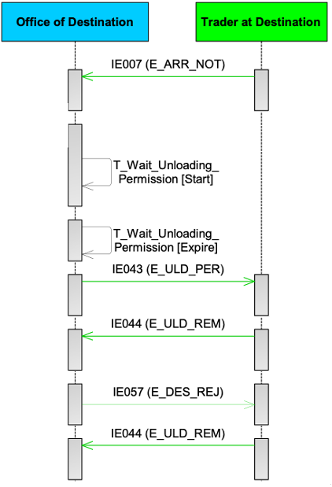
Figure 22: T-TRA-DES-E-007-Unloading remarks rejected

T-TRA-DES-E-003-Rejection of arrival notification
This scenario describes the case when the Trader at Destination sends the ‘Arrival Notification’ E_ARR_NOT (IE007) to an Actual Office of Destination that is invalid in terms of message structure and R/Cs.
[Step 1] The Trader at Destination sends the ‘Arrival Notification’ E_ARR_NOT (IE007) to the Office of Destination and NTKS performs validation of this message. If the ‘Arrival Notification’ E_ARR_NOT (IE007) has been found invalid after validation (i.e. in terms of message structure and R/Cs), NTKS rejects it.
[Step 2] The Office of Destination notifies the Trader at Destination by sending the ‘Rejection from Office of Destination’ E_DES_REJ (IE057) message.
The state of the movement at the Office of Destination remains unchanged.
[Step 3] The Trader at Destination sends again another ‘Arrival Notification’ E_ARR_NOT (IE007) to the Office of Destination and NTKS performs validation of this message. This time, the ‘Arrival Notification’ E_ARR_NOT (IE007) has been found valid after validation (i.e. in terms of message structure and R/Cs), NTKS accepts it.
The state of the movement at the Office of Destination is set to Arrival accepted. The state of the movement at the Office of Departure is set to Arrived.
[Step 4] In case of simplified procedure at the Office of Destination, the timer T_Wait_Unloading_Permission starts.

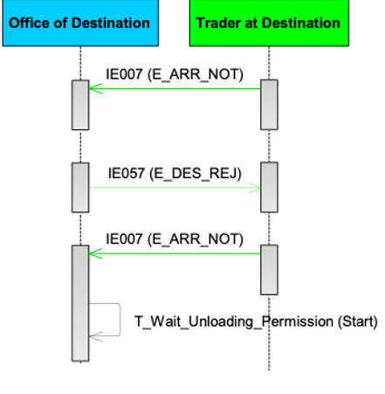
Figure 23: T-TRA-DES-E-003-Rejection of arrival notification

Control of the Goods at Destination
After receiving the ‘Arrival Notification’ E_ARR_NOT (IE007) message from the Trader at Destination (normal or simplified procedure), the Customs Officer at Destination takes decision whether the goods are to be controlled or not. If the decision is to control, then physical or documentary control is to be performed. It should be noted that if the goods are under simplified procedure, the timer “Wait for automatic unloading permission” is stopped.
The outcome of control can be either satisfactory or unsatisfactory:
- In case of satisfactory control results, the movement is written off at the Office of Departure;
- In case of unsatisfactory control results, the goods cannot be released from transit until the major discrepancies are fully resolved.
The following scenarios describe what happens when major discrepancies are detected during control at the Office of Destination.

T-TRA-DES-A-008-Major Discrepancies found during control at the Office of Destination – Resolved before the expiration of resolution timer
The unsatisfactory control results are when there are goods of the consignment that are missing, or other major discrepancies are discovered during control after the consignment has been presented at the Office of Destination (i.e. transit procedure ended incorrectly). The transit movement cannot be closed since not all major discrepancies are resolved.
According to this scenario, when major discrepancies are reported, they are resolved and their resolution justifies that the movement can be closed.
[Step 1] Control is performed at the Office of Destination and major discrepancies are reported into the destination control results. The Office of Departure is notified of unsatisfactory control results.
The state of the movement at the Office of Destination is set to Waiting for discrepancies resolution, while the state of the movement at the Office of Departure is set to Movement under resolution.
[Step 2] The Office of Destination sends the ‘Goods Release Notification’ E_GDS_REL (IE025) message to the Trader at Destination in order to notify them that the transit procedure has not ended correctly at the Office of Destination due to the existence of major discrepancies in the destination’s control results (i.e. Release indicator is NOT equal to ‘1- Full release of goods (as per declaration) - Movement closed’).
Alternatively, the Office of Destination may indicate in the first ‘Goods Release Notification’ E_GDS_REL (IE025) message that no consignment item of the transit movement can be released to the next procedure (i.e. Release indicator is set to ‘4- No release’).
[Step 3] Upon receiving notification that the transit procedure has ended incorrectly at the Office of Destination, the Office of Departure notifies the Holder of the Transit Procedure that major discrepancies are reported in the destination control results with the ‘Discrepancies’ E_DIS_SND (IE019) message. It should be noted that the sorting out and the resolution of the discrepancies is a paper-based procedure that is handled outside NTKS.
[Step 4] Upon receiving notification that the transit procedure has ended incorrectly at the Office of Destination, the timer T_Discrepancies_Resolution at the Office of Departure starts.
[Step 5] When the Office of Departure resolves the major discrepancies in the destination control results, the Office of Departure then notifies the Office of Destination.
The state of the movement at the Office of Departure is set to Movement written off, while the state of the movement at the Office of Destination is set to Goods released.
[Step 6] The Office of Destination sends the ‘Goods Release Notification’ E_GDS_REL (IE025) message to the Trader at Destination in order to notify them that the transit procedure has ended successfully, and for instance all the goods can be released from transit (i.e. Release indicator is equal to ‘1- Full release of goods (as per declaration) - Movement closed’).
[Step 7] The Office of Departure sends the ‘Write-Off Notification’ E_WRT_NOT (IE045) message to the Holder of the Transit Procedure for the discharge of the transit procedure.
[Step 8] The timer T_Discrepancies_Resolution at the Office of Departure stops
Upon completion of the above steps, the business flow of the transit procedure ends here.
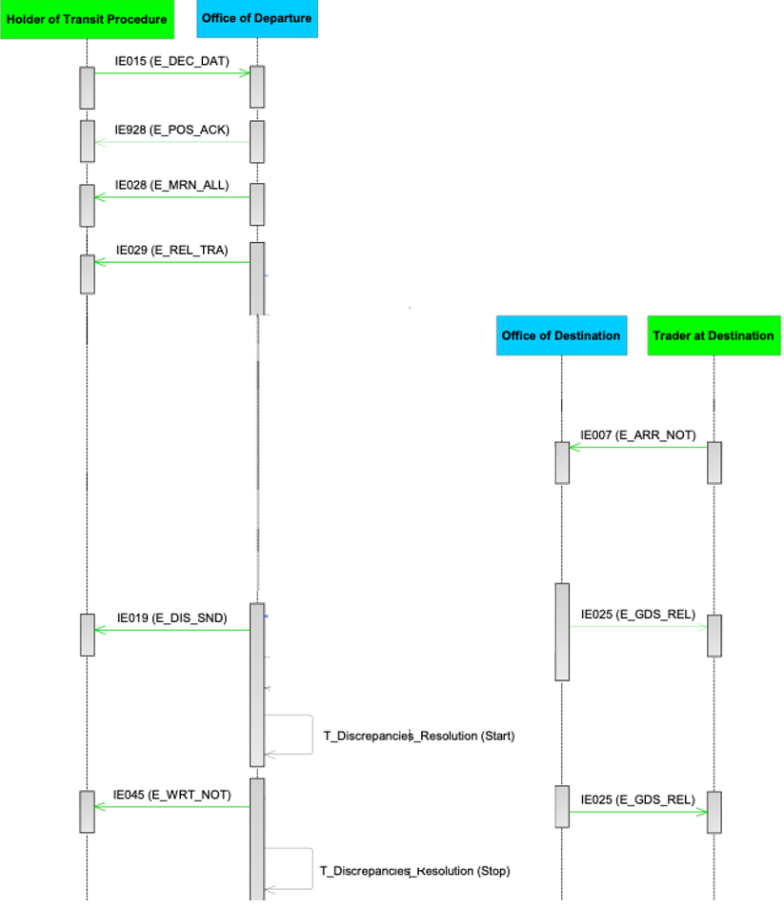
Figure 24: T-TRA-DES-A-008-Major Discrepancies found during control at the Office of Destination – Resolved before the expiration of resolution timer

Specific Scenarios for Incidents “En Route” (INC)
During the movement of goods under the Union or common transit procedure, incidents En-Route can happen. For instance, we may have one or more of the following incidents:
- the carrier is obliged to deviate from the prescribed itinerary due to circumstances beyond their control;
- seals are broken or tampered during transportation for reasons beyond the carrier's control;
- goods are transferred from one means of transport to another;
- imminent danger necessitates immediate partial or total unloading of the sealed means of transport;
- an event occurs which may affect the ability of the Holder of the Transit Procedure or the carrier to comply with their obligations;
- etc.
Without any undue delay after the incident, the carrier presents the goods together with the MRN of the transit declaration to the nearest customs Office of the National Administration in whose territory the means of transport is located at that time. This customs Office is named the Office of Incident Registration.

T-TRA-INC-M-001-Capturing movement information at Office of Incident Registration
The Union or Common transit movement is located at the Office of Incident Registration and the Customs Officer first looks up the MRN of the transit declaration in NCTS.
[Step 1] The Office of Incident Registration always requests the movement information from the Office of Departure in order to be informed about the latest state and details of the transit movement by the Office of Departure.
[Step 2] The movement information is found at the Office of Departure, and the Office of Departure sends it to the Office of Incident Registration.
[Step 3] The Office of Incident Registration registers the Incident and then sends the incident information to the Office of Departure.
Afterwards, the Customs Officer at the Office of Incident Registration proceeds with deciding whether the transit movement can continue its journey based on the state of the movement. This decision is taken based on the state of the movement at Departure. For instance, the movement may have already been written-off or arrived or under Recovery procedure and that means the movement must stop at the Office of Incident Registration. Otherwise, the Customs Officer at the Office of Incident Registration registers the incident information and afterwards decides that the movement can continue its journey. This means the consignment is allowed to leave from the Office of Incident Registration.
The state at the Office of Incident Registration is set to Incident registered.
Upon reception of the incident information, the [Step 4] Office of Departure forwards the incident information to the Holder of the Transit Procedure through the ‘Forwarded Incident Notification To ED’ E_INC_NOT (IE182) message.
NOTE: The nearest Customs Office for the registration of incident(s) must be located in the same Contracting Party as the place where the incident occurred.
NOTE: The movement is released for transit and an incident may immediately occur. In that case, the Office of Incident Registration is the same Office as the Office of Departure. Therefore, the Office of Departure will act as Office of Incident Registration.
In case the Office of Departure cannot locate the movement information, it is communicated to the Office of Incident Registration. The business flow of the transit procedure ends here for the Office of Incident Registration.

Enquiry & Recovery

T-ENR-ENQ-Handle Enquiry (ENQ)
The Enquiry process can be initiated when either the time allotted for the receipt of arrival advice from the Office of Destination, or the time for receipt of the control results from the Office of Destination has expired. The Office of Departure sends a request for information (Enquiry) to the Holder of the Transit Procedure within a period of (7) seven days after the expiry of any of the two times allotted. However, if, before the expiry of those time-limits, the Competent Authority of Enquiry at Departure receives information that the transit procedure has not ended correctly, or suspects that to be the case, it shall send the request without delay.
The Competent Authority of Enquiry at Departure initiates the Enquiry procedure by checking if they have received the arrival advice. The timer “Time to Enquire Holder on non-arrived movement” starts.
If the arrival advice was not received on time, the Competent Authority of Country of Departure checks the information on the Consignee and decides whether the information is sufficient or not. If it is considered insufficient, the Competent Authority sends the ‘Request on Non-Arrived Movement’ E_REQ_MOV (IE140) to the Holder of the Transit Procedure, the timer “Time to Enquire Holder on non-arrived movement” stops and the timer “Wait for response IE141” starts. The Holder of the Transit Procedure must react within the time limit of twenty-eight (28) days and send the ‘Information about Non-Arrived Movement’ E_MOV_RSP (IE141) message. If no information is provided within the time limit, it is considered to be a negative answer and decision is taken by the Competent Authority of Enquiry, whether Recovery has to be initiated or Enquiry to be continued with the Office of Destination.

T-ENR-ENQ-A-005-Holder of the transit procedure responds with sufficient information or alternative proof and movement closed
This scenario shows what happens when the time limit for the reception of the ‘Arrival Advice’ or ‘Destination Control Results’ has expired and the Competent Authority of Enquiry at Departure has no information about the movement.
The Competent Authority of Enquiry at Departure does not have sufficient information, that would allow for the discharge of the transit procedure, sends a ‘Request on Non-Arrived Movement’ E_REQ_MOV (IE140) message to the Holder of the Transit Procedure. The Holder of the Transit Procedure responds within the time limit with the ‘Information about Non-Arrived Movement’ E_MOV_RSP (IE141) message. The movement is then written off manually by the Office of Departure.
[Step 1] The time-limit for reception of ‘Arrival Advice’ or ‘Destination Control Results’ has expired.
[Step 2] The timer T_Notify_IE140 starts.
[Step 3] The timer T_Notify_IE140 stops since the Competent Authority of Enquiry at Departure decides how to proceed with the enquiry procedure. Due to the insufficient information about the movement, the Competent Authority of Enquiry at Departure initiates Enquiry. The state is set to Under enquiry procedure.
[Step 4] The Competent Authority of Enquiry at Departure does not have sufficient information that would allow for the discharge of the transit procedure and therefore sends a [Step 5] ‘Request on Non-Arrived Movement’ E_REQ_MOV (IE140) message to the Holder of the Transit Procedure. The [Step 6] timer T_Wait_Response_IE141 starts.
The Holder of the Transit Procedure responds within the time limit with the [Step 7] ‘Information about Non-Arrived Movement’ E_MOV_RSP (IE141) message providing sufficient information or the alternative proof provided by the Holder of the Transit Procedure. The [Step 8] timer T_Wait_Response_IE141 stops.
The response of the Holder of the Transit Procedure via the ‘Information about Non-Arrived Movement’ E_MOV_RSP (IE141) message enables the Customs Officer to write off the movement manually.
The business process of the transit operation ends here.

T-ENR-ENQ-A-009-Insufficient information–Holder of the transit procedure provides negative response
This scenario shows what happens when the time limit for the reception of the ‘Arrival Advice’ or ‘Destination Control Results’ has expired and the Competent Authority of Enquiry at Departure does not have sufficient information for the transit movement and sends a ‘Request on Non-Arrived Movement’ E_REQ_MOV (IE140) message to the Holder of the Transit Procedure. The Holder of the Transit Procedure responds within the time limit with the ‘Information about Non-Arrived Movement’ E_MOV_RSP (IE141) message. However, the information provided by the Holder of the Transit Procedure legitimates Recovery that is initiated by the Competent Authority of Recovery at Departure.
[Step 1] The time-limit for reception of ‘Arrival Advice’ or ‘Destination Control Results’ has expired.
[Step 2] The timer T_Notify_IE140 starts.
[Step 3] Due to the insufficient information about the movement, the Competent Authority of Enquiry at Departure initiates Enquiry. The state is set to Under enquiry procedure.
The [Step 4] Competent Authority of Enquiry at Departure does not have sufficient information that would allow for the discharge of the transit procedure and therefore sends a ‘Request on Non-Arrived Movement’ E_REQ_MOV (IE140) to the Holder of the Transit Procedure. The [Step 5] timer T_Notify_IE140 stops and the [Step 6] timer T_Wait_Response_IE141 starts.
[Step 7] The Holder of the Transit Procedure responds within the time limit with the ‘Information about Non-Arrived Movement’ E_MOV_RSP (IE141) message. [Step 8] The timer T_Wait_Response_IE141 stops.
The information provided by the Holder of the Transit Procedure is negative.
The Competent Authority of Recovery at Departure decides to initiate Recovery. Therefore, the state at the Competent Authority of Recovery at Departure is set to Under recovery procedure.
The business process of the transit operation ends here.

T-ENR-REC-Handle Recovery (REC)
The Recovery procedure usually starts as a follow up to the Enquiry procedure. The Recovery can be initiated if the goods never arrive at any Office of Destination, or alternatively when the goods have arrived, but major discrepancies have been identified by the Customs Office of Destination. Other than that, in any state after the movement was released for transit (when a Customs Officer in the Competent Authority of Recovery - in any country – has good reasons to suspect that a fraud or another abnormal incident took place).
[Step 1] Competent Authority of Recovery at Departure start Recovery.
The Customs Officer at the Competent Authority of the Recovery at Departure performs the Recovery at departure. The state of the movement at the Office of Departure is set to Under recovery procedure.
[Step 2] The Holder of the Transit Procedure is notified with the ‘Recovery Notification’ E_REC_NOT (IE035) message.
The state of the movement at the Competent Authority of Recovery at Departure is set to Under recovery procedure.
The Competent Authority of Recovery at Departure completes Recovery.
[Step 3] Finally, the ‘Write-off Notification’ E_WRT_NOT (IE045) message is sent to the Holder of the Transit Procedure.
The state of the movement at the Office of Departure is set to Movement written off.
The business process of the transit procedure ends here.

Introduction to ETD (Electronic Transport Document)
The Electronic Transport Document (ETD) is a customs procedure used for goods leaving and/or transiting the customs territory by air, where transport information submitted electronically replaces certain traditional transport documents. ETD supports the electronic exchange of transport-related data between economic operators (traders, carriers, logistics providers) and Customs authorities.

ETD is designed to integrate seamlessly with existing customs systems and processes, minimizing operational impact on the private sector.

Relationship between ETD and NCTS at Departure
From a procedural and technical perspective, the ETD process closely follows the standard NCTS declaration flow at departure.
- The submission process,
- The validation rules,
- The risk analysis, and
- The message exchange sequence

are aligned with those used for a standard NCTS declaration.
The key difference lies in the declaration dataset, which reflects transport-specific information required for ETD rather than the full NCTS transit dataset.

With the exception of the declaration data elements, the operational flow for ETD is equivalent to an NCTS declaration at departure.

This approach allows traders and system providers to reuse existing NCTS implementations, requiring only limited adaptations for ETD.

Additional Declaration Type Rules
The value of AdditionalDeclarationType shall be restricted based on the declaration type as follows:
- For Standard Declarations, the AdditionalDeclarationType may only take one of the following values:
['A', 'D']
- For ETD Declarations, the AdditionalDeclarationType may only take the following value:
['E']
Any deviation from the above combinations shall result in a validation error.

Guarantee Requirement
For ETD declarations, the provision of a Guarantee is not required. Therefore, no Guarantee data elements need to be submitted as part of the ETD declaration dataset, and related validation rules shall not be enforced.

Arrival at Destination – Air Transport (ETD)
For goods arriving by air, the arrival process under ETD follows the same principles as the standard NCTS arrival procedure. The overall workflow, controls, and message exchanges between the private sector and Customs remain aligned with NCTS.

The key difference is related to the timing of the arrival declaration.
Under ETD, the holder of the transit procedure is required to submit the arrival declaration prior to the physical arrival of the goods. This pre-arrival information is submitted using the ETD001 message.

The ETD001 message enables Customs to:
- Receive advance notification of the incoming goods,
- Perform risk analysis prior to arrival, and
- Prepare the subsequent arrival processing in line with NCTS principles.

All subsequent processing at arrival, including controls and notifications, follows the standard NCTS logic, unless explicitly stated otherwise in this specification.

Message Exchange Principles
The message exchange between Customs and the private sector for ETD mirrors the NCTS messaging model.
- Message structures
- Message sequencing
- Technical acknowledgement and error handling
remain consistent with NCTS.
To clearly distinguish ETD messages from standard NCTS messages, ETD-specific message identifiers are used.

Message Naming Convention
- NCTS messages are identified using the prefix:
IEXXX
- ETD messages use the corresponding prefix:
ETDXXX
Apart from the message identifier, the functional role of each message remains unchanged.
For example:
- Submission, acceptance, rejection, control decisions, and notifications
follow the same logical flow as in NCTS.

The table below illustrates the mapping between NCTS messages and their corresponding ETD messages.

NCTS Standard Message | ETD Equivalent Message | Description
IE001 | ETD001 | Anticipated Arrival Record (Declaration Data at destination)
IE004 | ETD004 | Amendment Acceptance
IE007 | ETD007 | Arrival Notification
IE009 | ETD009 | Invalidation Decision
IE013 | ETD013 | Declaration Amendment
IE014 | ETD014 | Declaration Invalidation Request
IE015 | ETD015 | Declaration Data (at departure)
IE025 | ETD025 | Goods Release Notification
IE028 | ETD028 | MRN Allocated
IE029 | ETD029 | Release for Transit
IE043 | ETD043 | Unloading Permission
IE044 | ETD044 | Unloading Remarks
IE046 | ETD046 | Response to Requested Documents
IE051 | ETD051 | No Release for Transit
IE056 | ETD056 | Rejection from Office of Departure
IE057 | ETD057 | Rejection from Office of Destination
IE060 | ETD060 | Control Decision Notification
IE906 | ETD906 | Functional NACK
IE917 | ETD917 | XML NACK
IE928 | ETD928 | Positive Acknowledge
Table 4: Mapping of standard NCTS messages and NCTS-ETD equivalent messages

APPENDICES
Appendices for NCTS-P6 External Domain:
- Appendix MSG contains the definition of external domain messages for NCTS-P6 including the ETD messages:
  - separate file LT-NTKS-TIS-EN-MSG-v4.00.pdf;
- Appendix XSD contains the XML Schemas of the external domain NCTS-P6 messages:
  - separate archive LT-NTKS-TIS-EN-XSD-v4.00.zip;
- Appendix XSD-ETD contains the XML Schemas of the external domain messages associated with ETD:
  - Separate archive LT-NTKS-TIS-EN-XSD-EDT-v4.0.0.zip;
- Appendix R of the DDNTA contains mapping of names of message data groups and data elements to names of XML elements of NCTS-P6 messages (element names have not changed in Phase 6 since Phase 5):
  - separate file DDNTA_APP_R-5.15.2-v2.00-SfA.pdf;
- Appendix SOAP contains the technical message exchange protocol for the external domain NCTS-P6 messages:
  - separate file LT-NTKS-TIS-EN-SOAP-v4.00.docx;
- Appendix TAD contains Guidelines for the Printout of the Transit Accompanying Document (TAD) and the Transit List of Items (TLoI) issued by DG TAXUD:
  - separate file NCTS-P5 Printing Guidelines - v.1.4 (18.09.2024).docx.

This National Administration also participates in NCTS.

